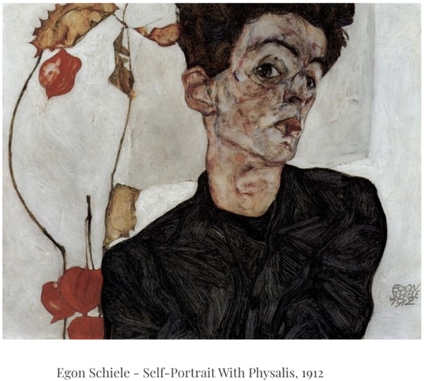
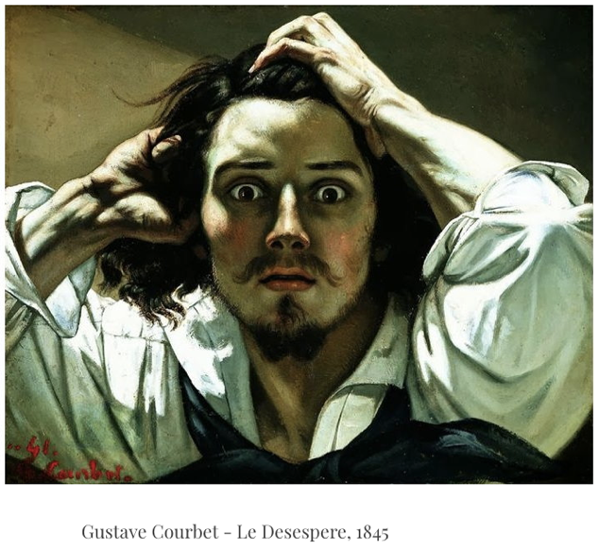
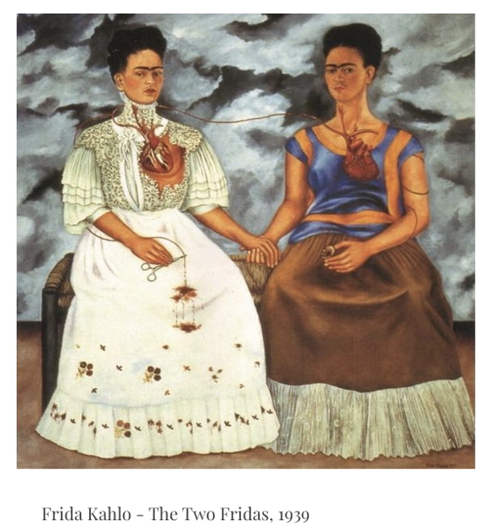
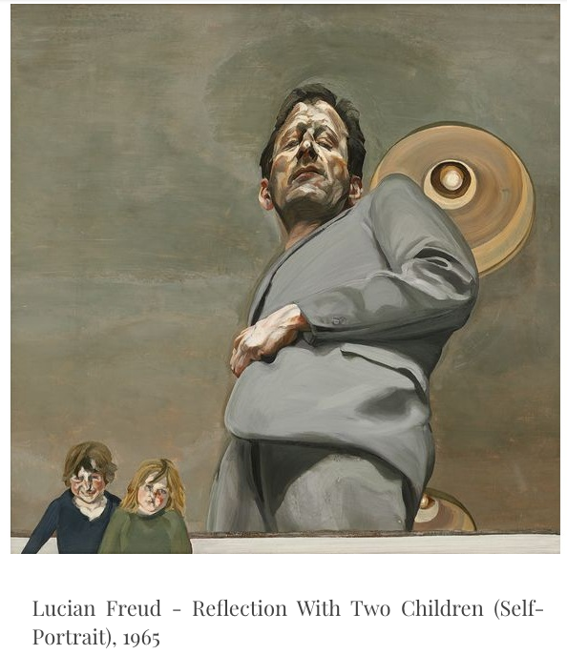

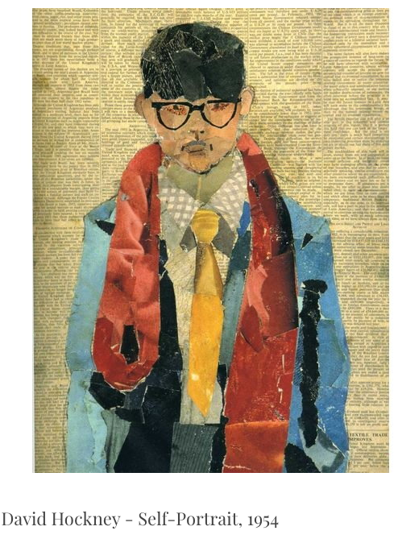
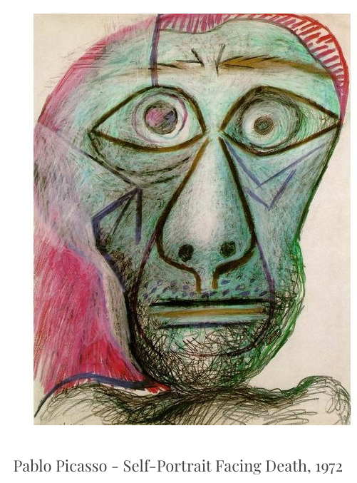
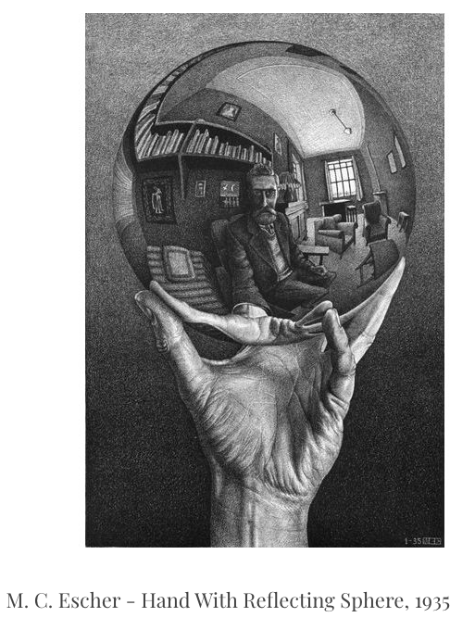
Choose at least three of the portraits and give your opinions using the substitution grids, or your own ideas.
How was this portrait made?

The self-portrait is:
- painted
- drawn using charcoal or pencil
- drawn using pastels or chalk
- collaged by sticking paper
The most noticeable part of the painting is the:

- artist’s face
- use of colour
- how the artist is looking out of the picture
- the background

because….
I like it / don’t like it because…

- it is scary and wild
- it makes me think of pain and suffering
- I think the artist is in pain
- The artist looks happy
- It is bright
- It is skilful
- It is fun and playful

It makes me feel:

- nervous
- exhilarated
- suspicious
- uneasy
- scared
- peaceful
- happy

because…

the point of view of the painter is:

- a forward view
- looking straight out of the canvas
- through another object
- side on
- staring wide eyed out of the painting

Name of painting:

Name of artist:

What perspective is used?

What stands out?
(give a reason)

Do you like it?
(give a reason)

How does it make you feel?
(give a reason)

Name of painting:

Name of artist:

What perspective is used?

What stands out?
(give a reason)

Do you like it?
(give a reason)

How does it make you feel?
(give a reason)

Name of painting:

Name of artist:

What perspective is used?

What stands out?
(give a reason)

Do you like it?
(give a reason)

How does it make you feel?
(give a reason)

Do you like it?

How does it make you feel?

