Adelita: the Mexican Cinderella – Traditional Tales
L/O: To be able to create different plots  by substituting ideas | What I  think |  | My teacher thinks
I can remember to:
Create an event which fits within a theme
Create an important item which relates to the event
Create a reason why the character needs to leave
Create a resolution
I can link my ideas together

 | Cinderella   | Adelita  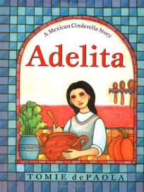 | Plot 1   | Plot 2
Invitation to... | The Grand Ball at the palace | The Gordillo family fiesta
Important item | Glass Slipper   | Embroidered, red shawl  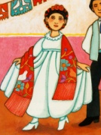
Had to leave because... | By midnight when the magic wore off. | By midnight before her stepsisters realised.
Resolution | The glass slipper fit Cinderella’s foot. | Adelita hung the shawl out of her window,
Ending | Married the prince | Married Javier

Sort the different plots into the table then think of your own examples for the next column.



