L/O: I can plan a traditional tale | What I  think |  | My teacher thinks
I can remember to:
Plan an opening (characters and setting)
Plan a build-up
Plan a problem
Plan a resolution
Plan an ending
Practise what I am going to write by saying it.

V orphan, invitation, godmother, midnight,

C for, and, nor, but, yet, so,
if, since, as, when, although, while, after, before, until, because

O A long time ago,
On the day of the fiesta,
When she arrived,
1. Opening
The following morning,
Main character:
Other characters:
Setting:

Extra details:

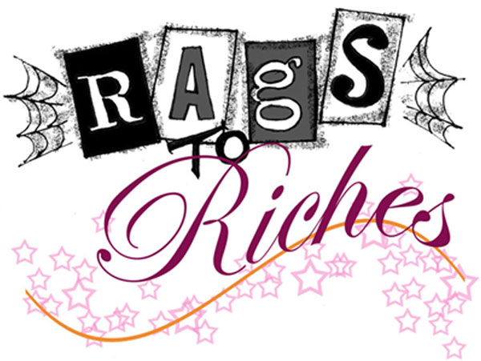Traditional Tale
P A . ? ! , ’ “ ”
5. Ending





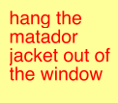

What are the characters invited to?

Who comes to help?

What is the important item of clothing?

2. Build-up
Why does your main character have to leave?

3. Problem!
How is the main character found?

4. Resolution

