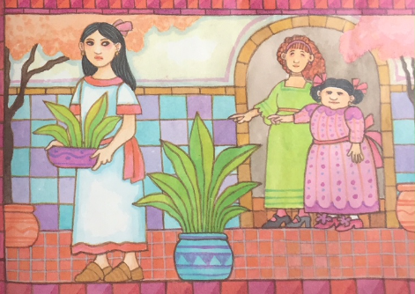
I love you Esperanza, you bring happiness to my life.
Adelita’s life became hard and her stepsisters were mean and hateful towards her.
“Clean our rooms, Adelita!” Dulce ordered sternly.
Adelita answered slowly and sadly, “Yes, stepsisters”.
Clean our rooms, Adelita!
Yes, stepsisters.

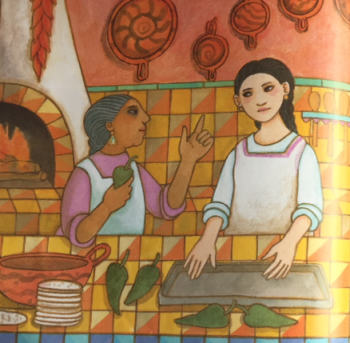
Adelita spent all of her time in the kitchen with her godmother Esperanza. The love that she felt from Esperanza made her heart as warm as the fire.
“I love you Esperanza. You bring happiness to my life.” Adelita murmured.
Esperanza sighed and replied, “I wish there was a way for me to make your life easier.”
I wish there was a way for me to make your life easier.

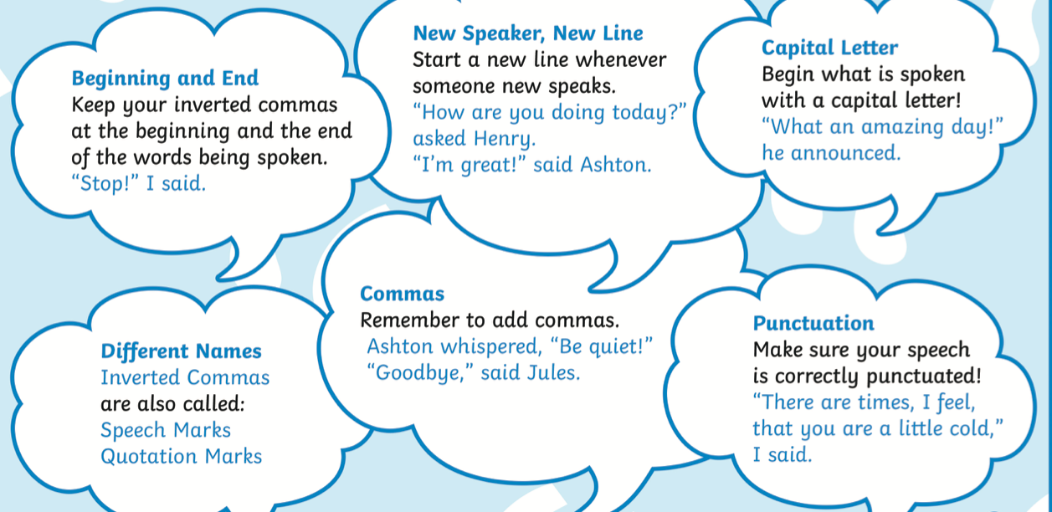

L/O: I can use direct speech accurately | What I  think | My teacher thinks
I can remember to:
Use inverted commas (speech marks) at the beginning and end of the speaking
Start a new speaker on a new line
Use punctuation inside of the speech marks
 before
Begin the speech with a capital letter

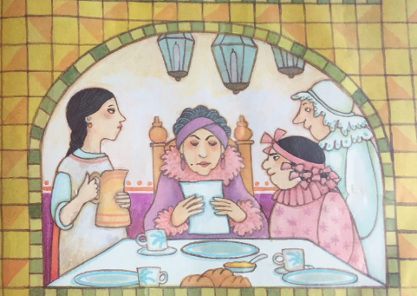
Change the speech bubbles into direct speech. Use the example and the remember tos to help you.
Oh, a fiesta sounds like a lovely treat!
Ha Ha, Adelita thinks she can go!
One day an invitation arrived to a great fiesta.
________________________________________ announced Adelita’s stepmother.
________________________________________________Said Adelita.
__________________________________________ Replied her mean stepsister

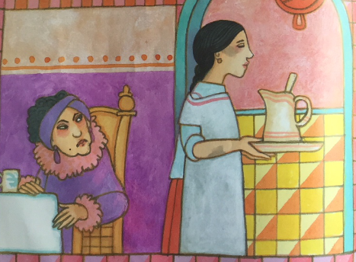

If you ever need me just call my name.
I will never forget this night Esperanza!
This time use the speech that is in the speech bubbles to write your own direct speech. Use your remember tos to help you.

Adelita asked her stepmother politely if she could go.
________________________________________ explained Adelita.

__________________________________ shouted her cruel stepmother!
I knew Senor Javier as a child. I would love to see him again,
You can’t go! Look at your dirty face. You would embarrass us all!
My dears, Senor Gordillo is having a fiesta at his ranch!

