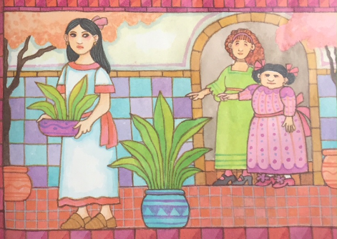
I love you Esperanza, you bring happiness to my life.
Adelita’s life became hard and her stepsisters were mean and hateful towards her.
“Clean our rooms, Adelita!” Dulce ordered sternly.
Adelita answered slowly and sadly, “Yes, stepsisters”.
Yes, stepsisters.


Adelita spent all of her time in the kitchen with her godmother Esperanza. The love that she felt from Esperanza made her heart as warm as the fire.
“I love you Esperanza. You bring happiness to my life.” Adelita murmured.
Esperanza sighed and replied, “I wish there was a way for me to make your life easier.”
I wish there was a way for me to make your life easier.

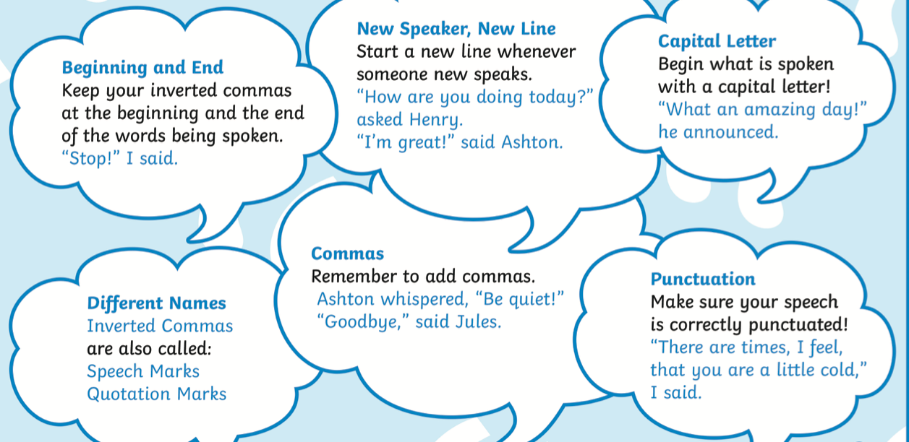

L/O: I can use direct speech accurately | What I  think | My teacher thinks
I can remember to:
Use inverted commas (speech marks) at the beginning and end of the speaking
Start a new speaker on a new line
Use punctuation inside of the speech marks
 before
Begin the speech with a capital letter

Use different words for said

Oh, a fiesta sounds like a lovely treat!
Change the speech bubbles into direct speech. Use the example and the remember tos to help you.

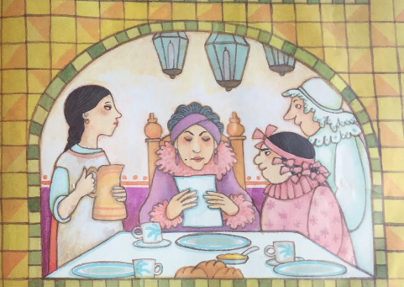
Ha Ha, Adelita thinks she can go!
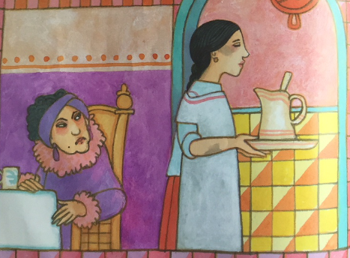

Clean our rooms, Adelita!
Use the story to fill in the speech bubbles and then write out the direct speech. As a challenge, use adverbs to show how they were speaking (e.g. loudly, sadly)
Adelita asked her fairy Godmother kindly,” Can you make me all beautiful so I can go to the party?”
Her fairy Godmother then replied with,” Yes”
Just as she said that she took her wand out and said,” Bibbidi bobbidi boo!!”
My dears, Senor Gordillo is having a fiesta at his ranch!
I knew Senor Javier as a child. I would love to see him again,
You can’t go! Look at your dirty face. You would embarrass us all!
yuAdelita was talking about going to the fiesta, “oh, a fiesta sounds like a lovely treat.”
Then her mean sisters said, “Ha ha, Adelita thinks she can go!”
Adelita’s stepmother then said, “My dears, senor Gordillo is having a fiesta at his ranch!”

Adelita said,”I knew Senor Javier as a child, I would love to see him again,”
Her mean stepmother then meanly replied with, ”You can’t go! Look at your dirty face. You would embarrass us all!”

