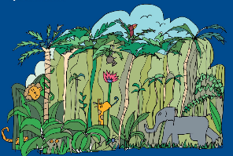
List Poem: 10 Things in an Explorer’s Rucksack

What an exciting, magical adventure to the jungle we’ve had! We’ve seen neon fish, pink skies and never-ending flapjacks!
We’ve written a list poem of magical things that can be found in our explorer’s rucksack.

