Y6 Literacy Homework – 25th January Name: _____________
Given how much we rely on it now, it is difficult to believe that the internet is still a very recent invention. Developed during the 1980s but only becoming popular in the early 2000s, it is probably impossible for you to imagine the world without it. This will not be the case for your parents and other family members.
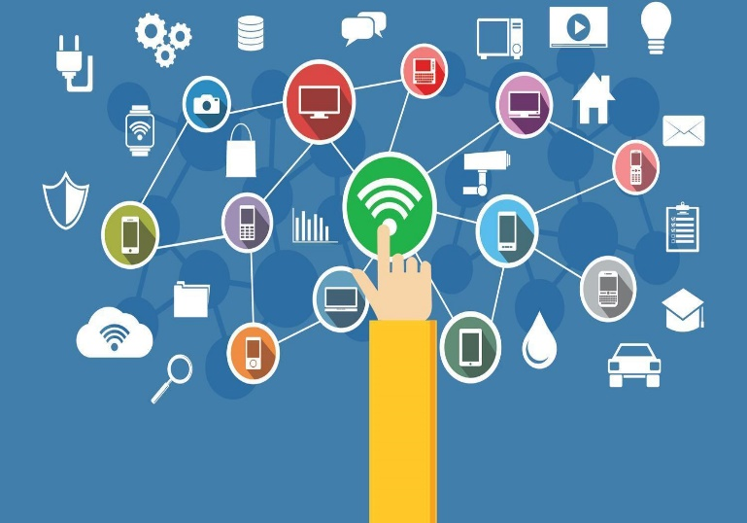
Your task this week is to interview a family member about life before the internet and the other technologies we take for granted today. How did they find information they needed? How did they keep in touch with family members? Where did they find their entertainment? The better questions you ask, the better the responses you will get.


______________________________________________________________________________________________________________________________________________________________________________________________________________________________________________________________________________________________________________________________________________________________________________________________________________________________________________________________________________________________________________________________________________________________________________________________________________________________________________________________________________________________________________________________________________________________________________________________________________________________________________________________________________________________________________________________________________________________________________________________________________________________________________________________________________________________________________________________________________________________________________________________________________
_______________________________________________________________________________________________________________________________________________________________
Below, tell me how you would have coped in an internet-free world.
__________________________________________________________________________________________________________________________________________________________________________________________________________________________________________________________________________________________________________________________________________________________________________________________________________________________________________________________________________________________________________________________________________________

