Y6 Literacy Homework – 18th January Name: _____________
Below is a picture of Robert Wadlow - the tallest human who has ever lived, who stood at a whopping height of 272cm or 8ft 11inches. Your task is to describe what a typical day would be like in his life. Write as if you are Robert and explain how the world looks from your elevated vantage point. Humour and descriptive language is very much encouraged!
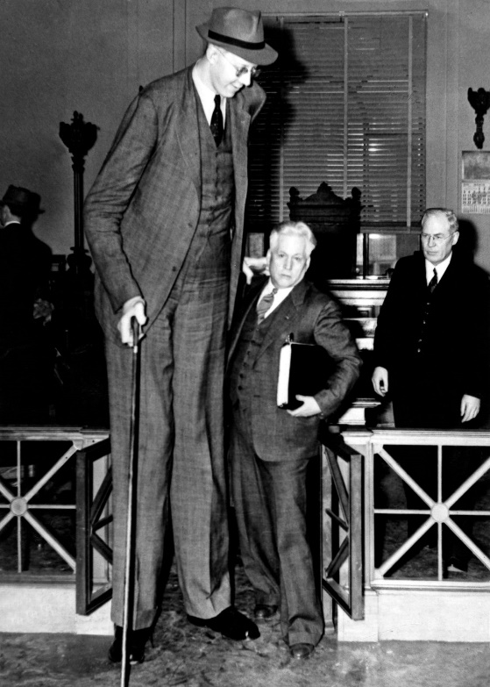
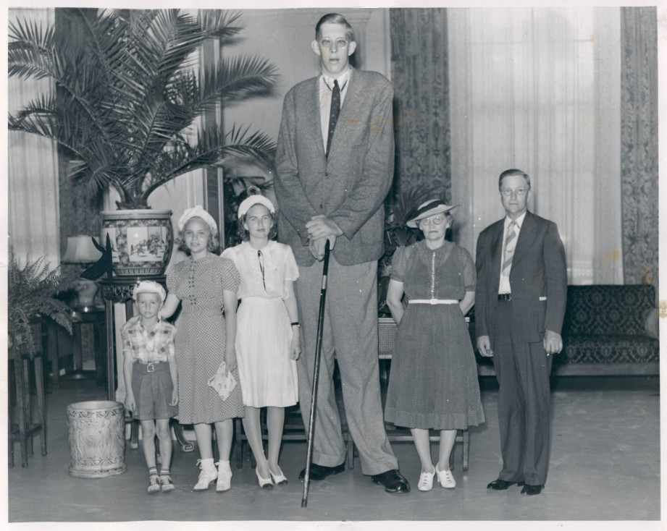

______________________________________________________________________________________________________________________________________________________________________________________________________________________________________________________________________________________________________________________________________________________________________________________________________________________________________________________________________________________________________________________________________________________________________________________________________________________________________________________________________________________________________________________________________________________________________________________________________________________________________________________________________________________________________________________________________________________________________________________________________________________________________________________________________________________________________________________________________________________________________________________________________________
Draw a picture below to show Robert going about an everyday activity!

