Y6 Literacy Homework – 16th November Name______________
Salutations Kensukes! In Y6 we try to emulate (copy) the red panda and it’s overwhelmingly positive approach to life and we know, that with the right mindset, adventure and enjoyment can be found in every task.
Your homework this week is to put yourself into the shoes of the red panda from the video below. I would like you to describe what is going through your boggled mind at the various stages of your encounter with the rock. Think about just how amazed that panda was; can you get that pure sense of wonder across in your writing?
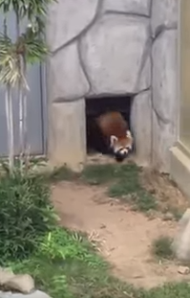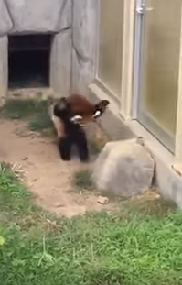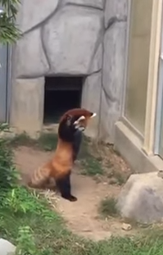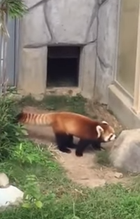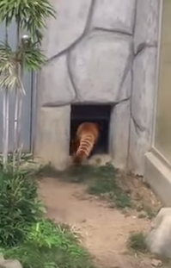
___________________________________________________________________________________________________________________________________________________________________________________________________________________________________________________________________________________________________________________________________________________________________________________________________________________________________________________________________________________________________________________________________________________________________________________________________________________________________________________________________________________________________________________________________________________________________________________________________________________________________________________________________________________________________________________________________________________________________________________________________________________________________________________________________________________________________________________________________________________________________________________________________________________________________________________________________
Draw yourself as a red panda below if you want!

