Y6 Literacy Homework – 12th October Name______________
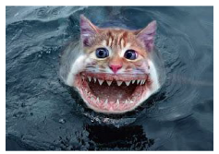
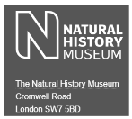
Hello there Kensuke! To tie in with your literacy and science work on evolution, I want you to put yourself into the shoes of the unique animal you are in the process of creating. Imagine, as that creature, that you have just seen a human for the first time (that human could be you!); what would you say about the experience? How would you describe what you saw? I’m going to leave the layout of this up to you as I’m highly intrigued to see what you come up with…
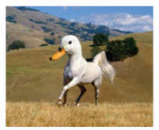


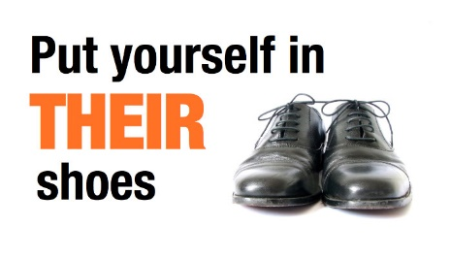

__________________________________________________________________________________________________________________________________________________________________________________________________________________________________________________________________________________________________________________________________________________________________________________________________________________________________________________________________________________________________________________________________________________________________________________________________________________________________________________________________________________________________________________________________________________________________________________________________________________________________________________________________________________________________________________________________________________________________________________________________________________________________________________________________________________________________________________________________________________________________________________________________________________________________________________________________________________________________________________________________________________________________________________________________________________________________Draw me a picture below to illustrate your text!

