Y6 Literacy Homework – 7th September 2017 Name:_____________
Now, although this is a highly unlikely thing to ever happen, as there is no harm in hoping, let’s go with it: you’ve found a magic lamp and, in that lamp, as is always the case, is a genie who has no choice but to grant you two wishes (due to austerity cuts, genies are not as generous nowadays). What are you going to wish for and why? Think carefully about your choices: what is likely to bring you the most happiness?
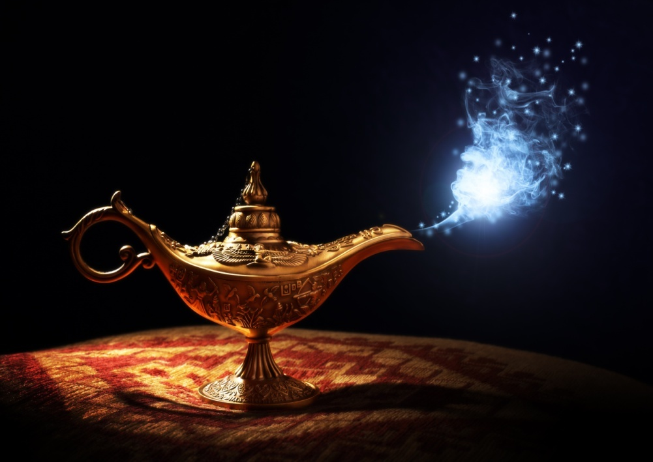

My 1st choice is _________________________________
_______________________________________________________________________________________________________________________________________________________________________________________________________________________________________________________________________________________________________________________________________________________________________________________________________________________________________My 2nd wish is ____________________________________ ______________________________________________________________________________________________________________________________________________________________________________________________________________________________________________________________________________________________________________________________________________________________________________________________________________________________________________________________________________________
Draw a picture below to illustrate one of your choices if you want!

