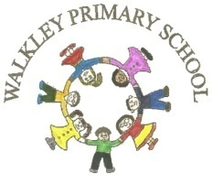 | Walkley Primary School – Y6 Learning Log 2019: Summer 2 |  |  |  |  |  |  |  |  |  |  | 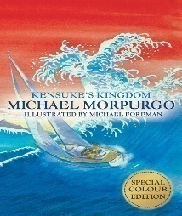
Last Half Term’s Topic: SATs and the end of WW1
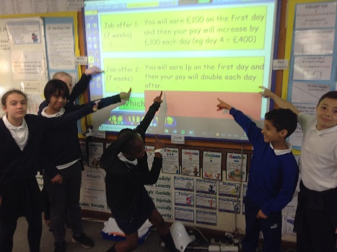 |  |  |  | 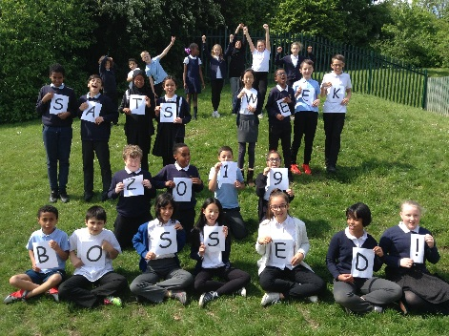 |  |  |  | 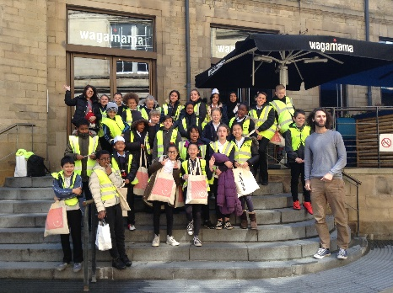
Learning Log Summer 2 – Victorians/Oliver!
It’s time for the final Learning Log of your Walkley careers intrepid Kensuke! For this momentous occasion, the focus is on the Victorian period of history with a strong emphasis on the story of Oliver Twist, a version of which we will be producing for our end of year production in July. Have a look at the choices below for inspiration but, as always, feel free to have a pop at anything else that tickles your fancy. Have fun! |  |  |  |  |  | It is expected that you complete at least 4 out of the 9 activities.  It would be GREAT if you could complete 5.  It would be AMAZING if you do 7 or more.
Practice the lyrics to songs from Oliver! Most will be in our production so get a head start. |  |  | Consider, for yourself, which role/roles you would like to have during the Oliver! production. They don’t all have to be acting. |  |  |  |  |  |  | Create a backstory for the history of Fagin, Artful Dodger, Nancy, Bullseye or Bill Sykes. What has happened in their pasts?
Draw/create an image connected to Oliver! or to another aspect of Victorian life. |  |  | Research the grisly fates that some Victorian children faced. |  |  |  |  |  |  | Compile a list of inventions and key developments (with dates) during the Victorian period.
Find twenty brand new ambitious words and use them in sentences. |  |  | Write your thoughts about coming to the end of your time as a Walkley pupil. What will you miss most? What are you looking forward to? |  |  |  |  |  |  | Enjoy reading a book. Enjoy yourself even more by reading two, three or four!
 |  |  |  |  |  |  | Parent/Carer Comments
  Every week in term time I must also: | What I think | What my teacher thinks
  Success Criteria: | What I think | What my teacher thinks
  - Complete my weekly English and maths homework tasks.
  - Practice my spellings and complete the weekly Spelling Log tasks
  - Read and discuss my reading each night.
  - Discuss with my grown-ups what I’m learning in school.

