 | Walkley Primary School – Y6 Learning Log 2019: Summer 1 |  |  |  |  |  |  |  |  |  |  | 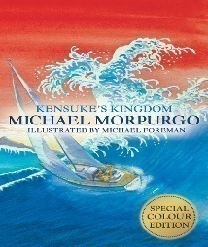
Last Half Term’s Topic: Life In the Trenches: WW1
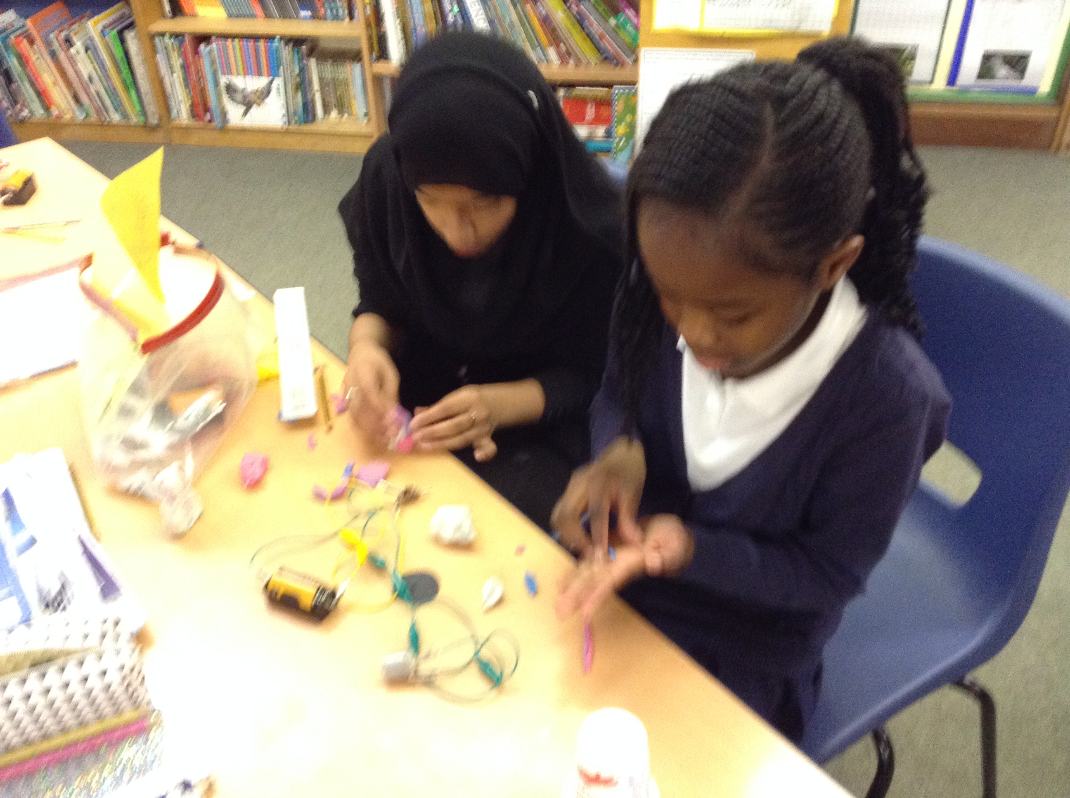 |  |  |  | 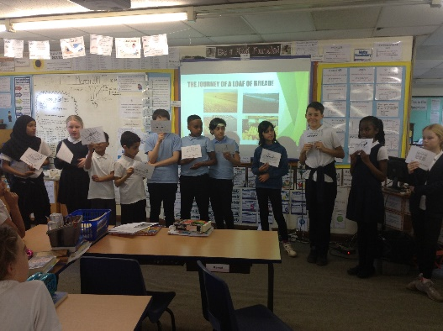 |  |  |  | 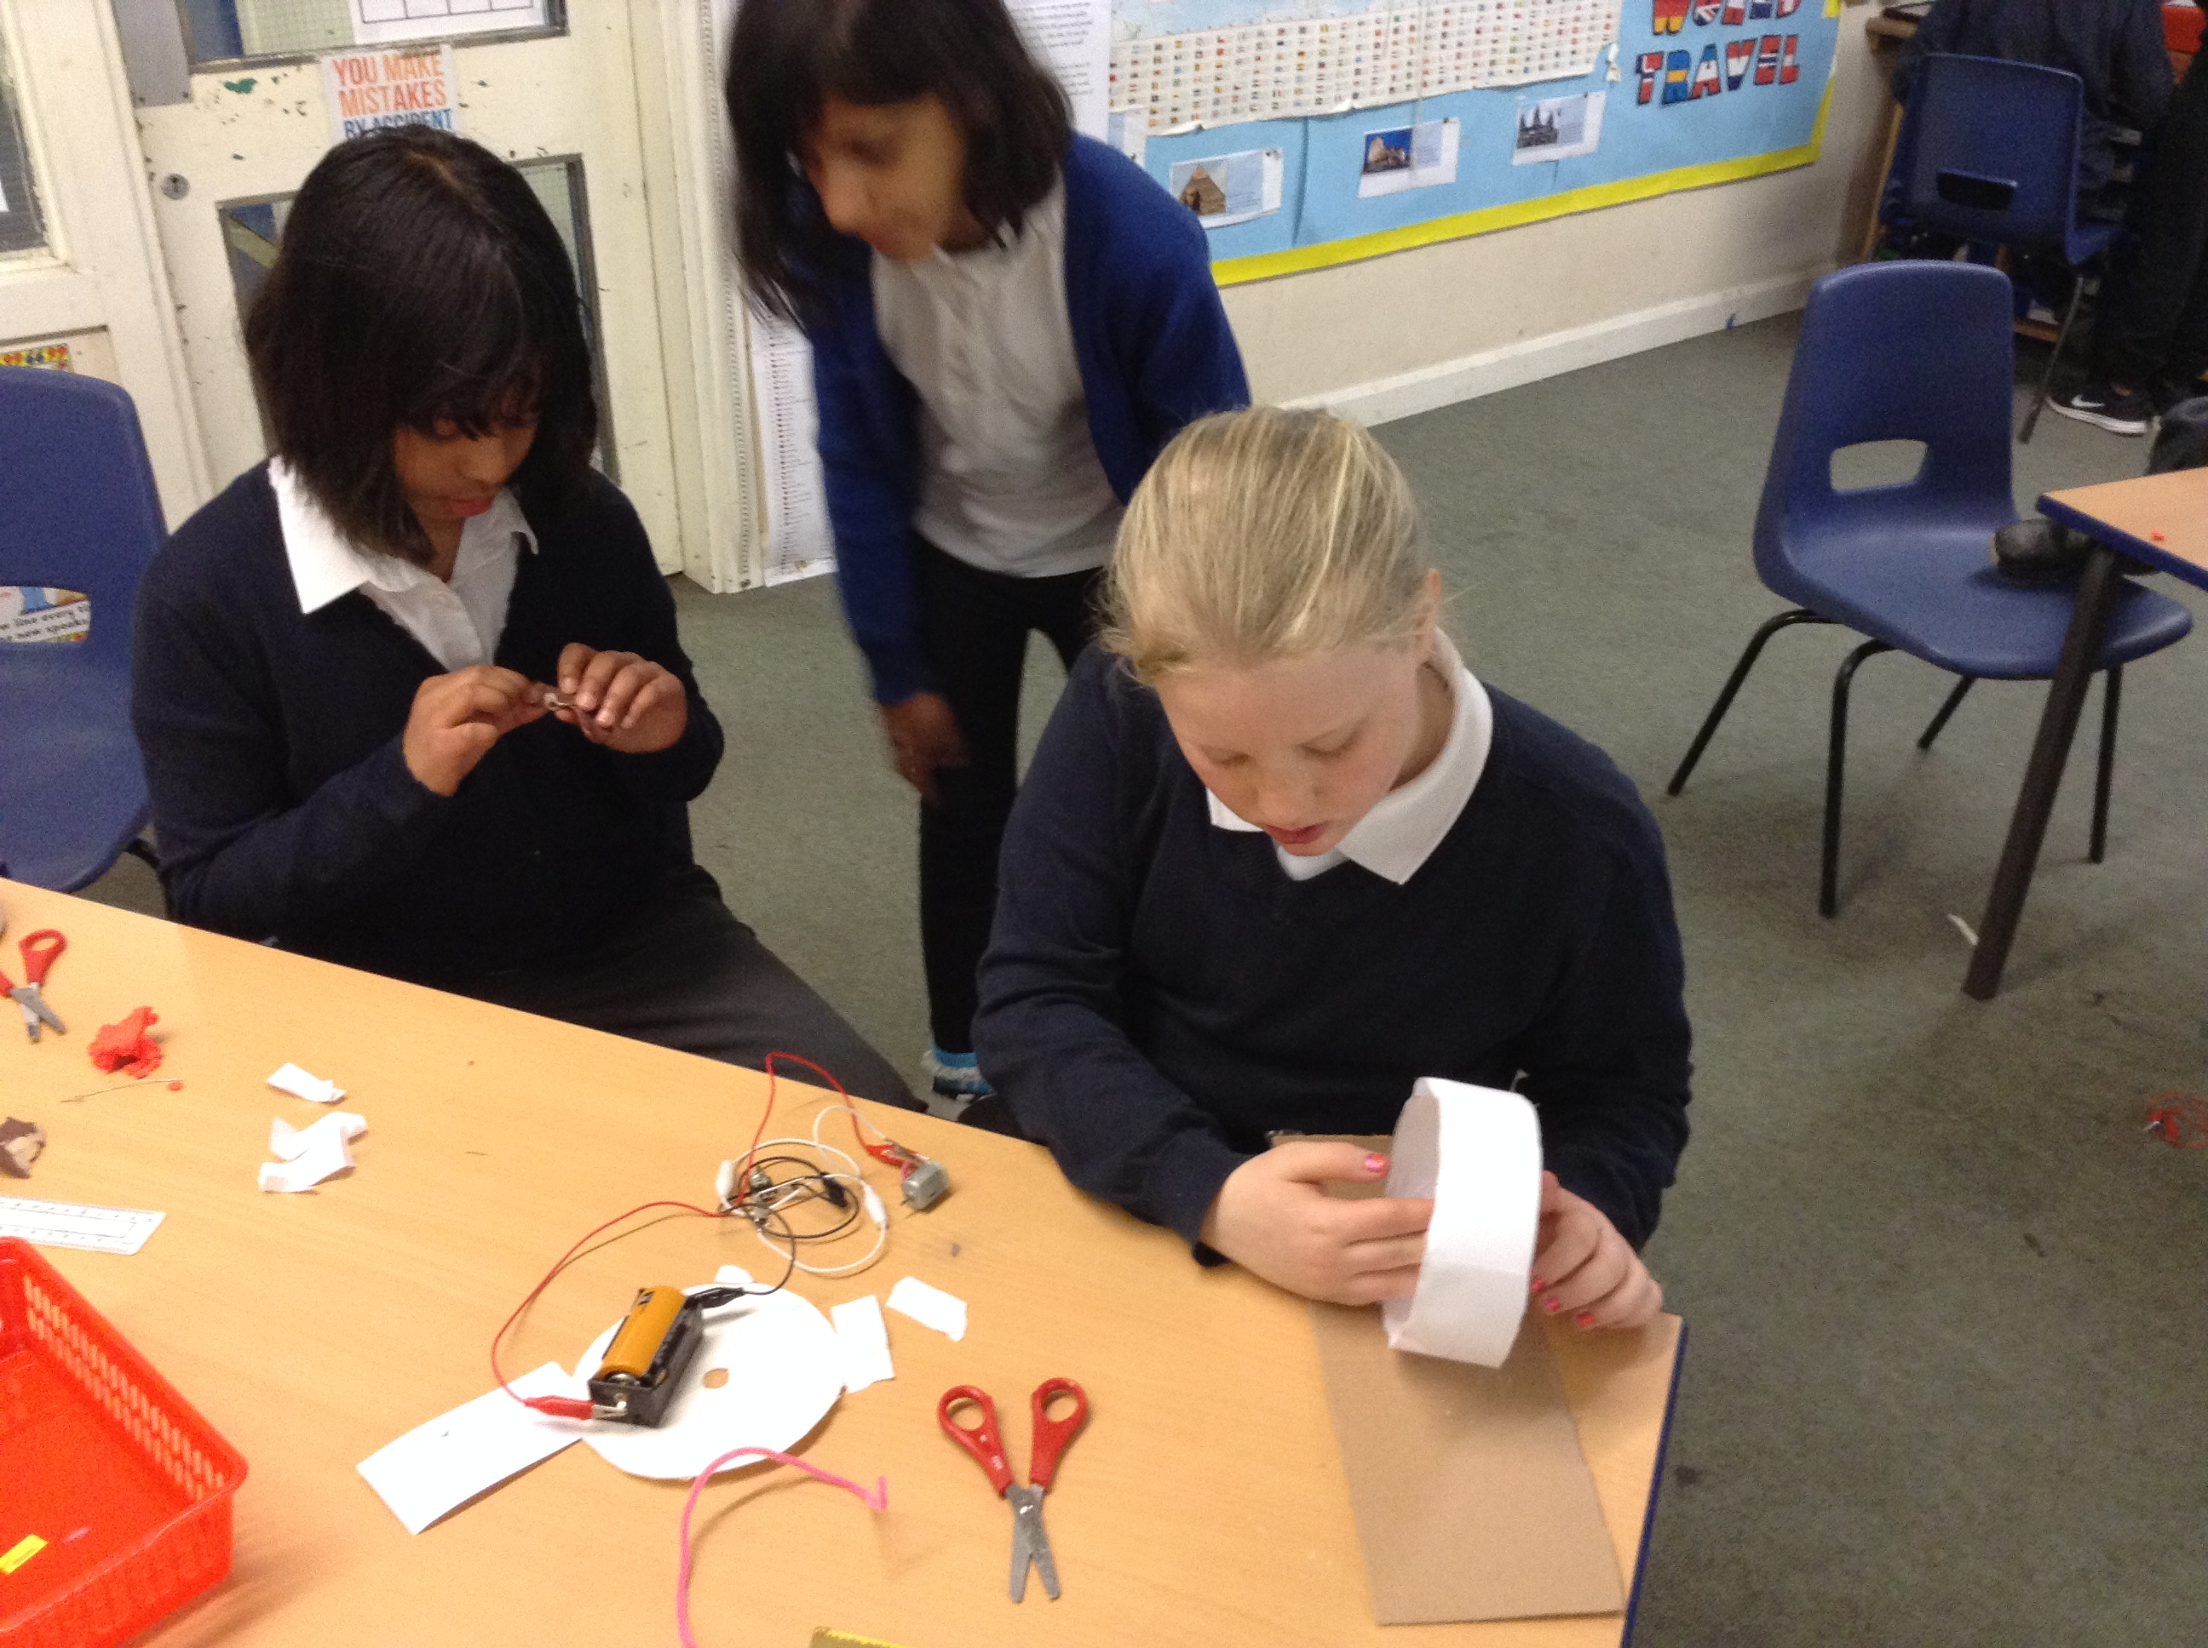
Learning Log Summer 1 – SATs Attack!
As is tradition at this stage in Y6, the Learning Log for Easter is focussed on making sure each Kensuke is ready for and feels confident about the SATs assessments which take place this year between Monday the 13th and Thursday the 16th of May (5th week back). Have a look at the task suggestions below but feel free to do anything else that could help. |  |  |  |  |  | It is expected that you complete at least 4 out of the 9 activities.  It would be GREAT if you could complete 5.  It would be AMAZING if you do 7 or more.
Look through the pack of practice SATs papers and see where your gaps are. |  |  | Keep a food diary of everything you eat and drink over the holiday. Can you work out your calorie intake? |  |  |  |  |  |  | Make a list of all the skills you need to have to get your dream job of the future.
Learn the Y5 & Y6 spelling words (a key requirement for the national tests). There’s a sheet in your packs. |  |  | Find twenty brand new ambitious words and use them in sentences. |  |  |  |  |  |  | Critically assess a book, TV show or film. What elements do they contain which just make no sense?
Create an original story which shows off your writing powers. Anything I can use for evidence of your skills will be ace! |  |  | Research the Victorian period of history. It will be our new topic after the holiday so let’s see what you can find out! |  |  |  |  |  |  | Enjoy reading a book. Enjoy yourself even more by reading two, three or four!
 |  |  |  |  |  |  | Parent/Carer Comments
  Every week in term time I must also: | What I think | What my teacher thinks
  Success Criteria: | What I think | What my teacher thinks
  - Complete my weekly English and maths homework tasks.
  - Practice my spellings and complete the weekly Spelling Log tasks
  - Read and discuss my reading each night.
  - Discuss with my grown-ups what I’m learning in school.

