 | Walkley Primary School 2018/2019  – Y6 Learning Log: Spring 2 |  |  |  |  |  |  |  |  |  |  | 
Last Half Term’s Topic: World War One
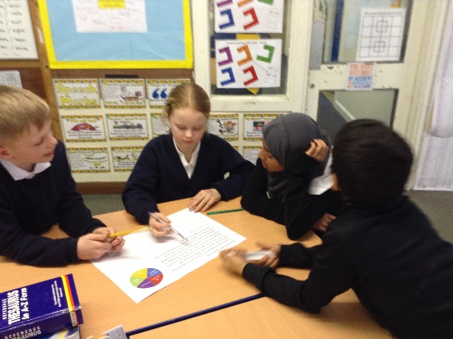 |  |  |  | 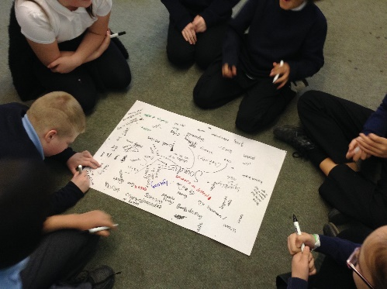 |  |  |  | 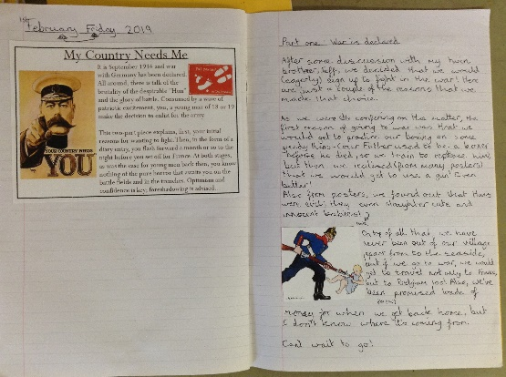
Learning Log Spring 2 – World War One (continuing until Easter)
Given how much we are finding out in this topic and how much we still have yet to cover, our World War One focus will continue into the second half of spring. As always, you have been provided with ideas but if there is something you would like to do related to the topic or completely different which is not on the list, feel free to do that. Your Learning Log = your choice! Have fun! |  |  |  |  |  | It would be GOOD if you could complete 4 or 5 activities.  It would be GREAT if you could use ICT in your work.  It would be AMAZING if you could complete a range of activities (write, research, make, discuss, draw)
Design a WW1 soldier’s uniform or a trench system. |  |  | Draw or make something connected to the trenches. |  |  |  |  |  |  | Research family members involved in WW1.
Design an anti-propaganda poster telling the truth about the war. |  |  | Compile facts about WW1 or investigate how the war ended. |  |  |  |  |  |  | Listen to and describe music that was popular around the time of WW1
Write a conversation between two soldiers meeting in No Man’s Land during the Christmas Truce. |  |  | Write an account either about your time at Castleton or at school while the others were away. |  |  |  |  |  |  | Review books that you read, films that you watch or games that you play during the break.
 |  |  |  |  |  |  | Parent/Carer Comments
  Every week in term time I must also: | What I think | What my teacher thinks
  Success Criteria: | What I think | What my teacher thinks
  - Complete my weekly English and maths homework tasks.
  - Practice my spellings and complete the weekly Spelling Log tasks
  - Read and discuss my reading each night.
  - Discuss with my grown-ups what I’m learning in school.

