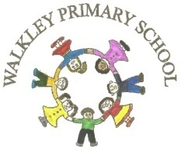 | Walkley Primary School –  Y6 Learning Log: Autumn 2 |  |  |  |  |  |  | 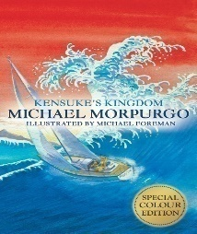
Last Term’s Focus: Welcome to your Y6 Kensukes! |  |  |  |  | Here are some examples of the children’s work carried out in Aut 1.
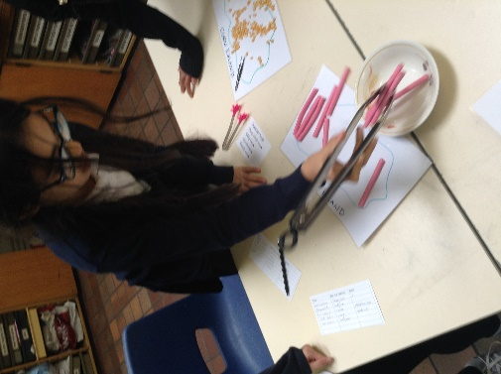 |  | 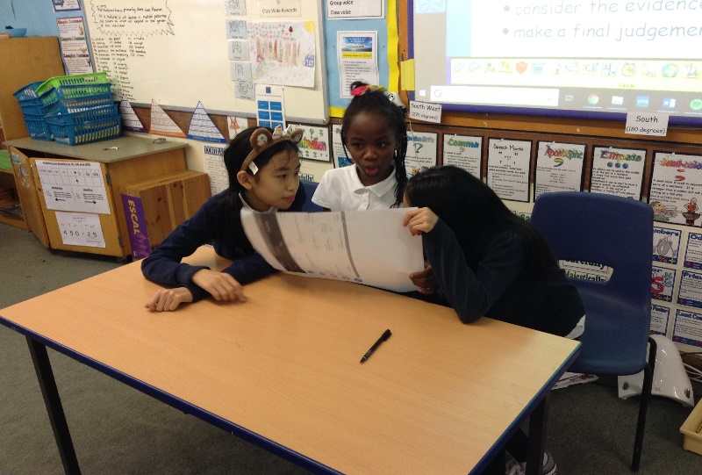 |  |  |  |  | 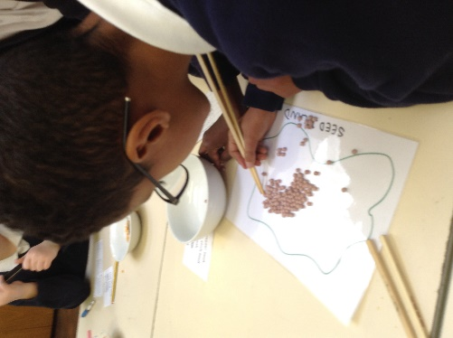
Learning Log Autumn 2 – The World Wars
To commemorate the 100-year anniversary of Remembrance Day and the end of The Great War, our topic this half-term will look at both this landmark event and the Second World War and the impact they had on both the people involved at the time and on the course of history since will be investigated. To prepare, a number of the tasks on this Learning Log are linked to this topic but, as always, if there is something you would else you would like to do related to the topic or completely different which is not on the list, feel free to do that. Your Learning Log = your choice! Have fun! |  |  |  | It would be GOOD if you could complete 4 or 5 activities.  It would be GREAT if you could use ICT in your work.  It would be AMAZING if you could complete a range of activities (write, research, make, discuss, draw)
Research what the cause of the two world wars was. What ended them? |  |  | Draw a picture showing the impact of the Blitz bombings in either London or Sheffield. |  |  | Devise activities that we could do as a class during circuit training in PE.
Listen and describe music made during the period 1939-1945. |  |  | List the countries involved in the two World Wars. Who were allies of the UK and who were enemies? |  |  | Make a model of an Anderson Shelter.
Talk to and interview somebody who was alive during World War 2. What do they remember? |  |  | Create a time line of key events for either WW1 or WW2. |  |  | Review the books that you read or films that you watch during the break. Any recommendations?

 | Parent/Carer Comments
  Every week in term time I must also: | What I think | What my teacher thinks
  Success Criteria: | What I think | What my teacher thinks
  - Complete my weekly English and maths homework tasks.
  - Practice my spellings and complete the weekly Spelling Log tasks
  - Read and discuss my reading each night.
  - Discuss with my grown-ups what I’m learning in school.

