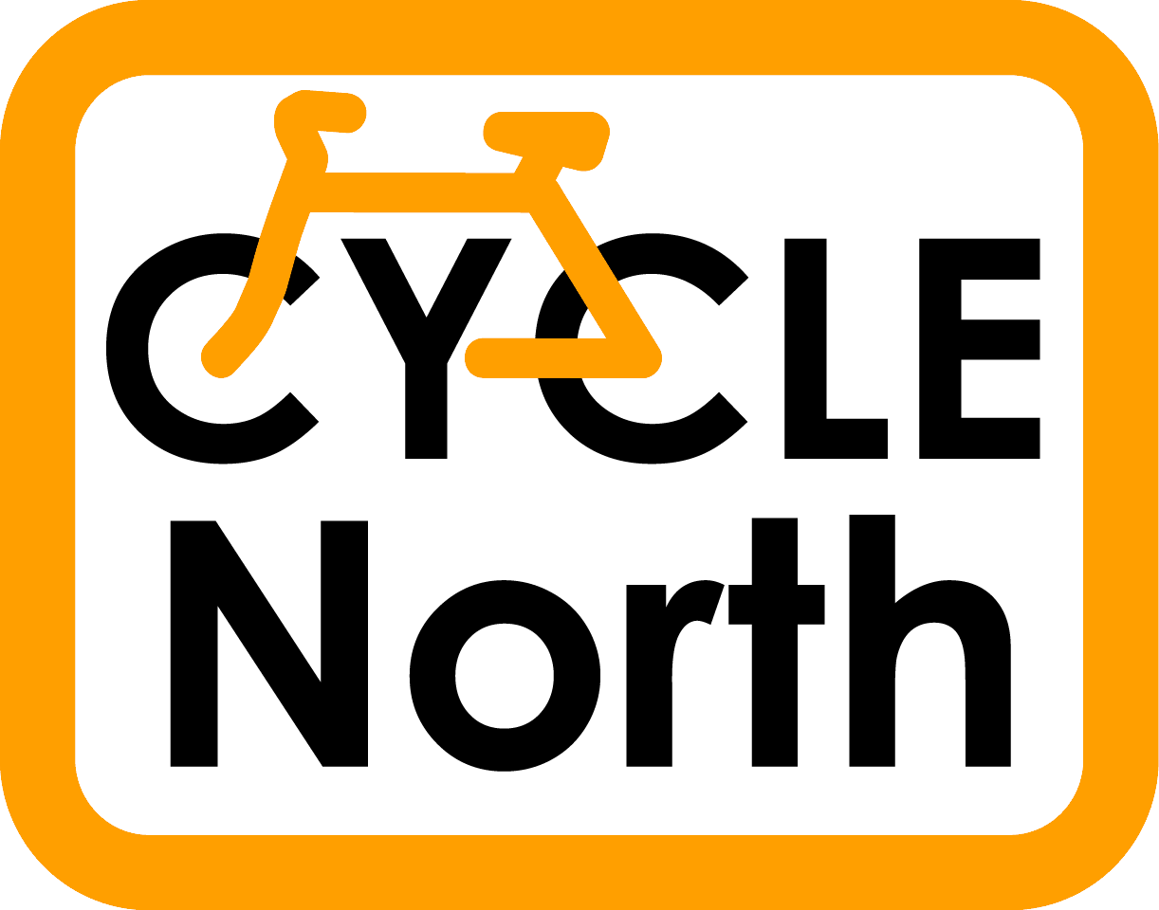

Walkley Primary School
Burnaby Crescent
Sheffield S6 2RZ
Tel: 0114 2340550
Fax: 0114 2310553
Email: enquiries@walkley.sheffield.sch.uk
Web: http://www.walkleyprimaryschool.org.uk
Headteacher: Val Sian
DeputyHeadteacher: Chris Wallis
Chair of Governors: Sian Holmes
6th November 2018
Bikeability Cycle Training
Dear Parent/Guardian

Your School has been chosen as one of a few schools in Sheffield to receive Bikeability Cycle Training. This course seeks to give children the skills and confidence to cycle safely on the road. This fun course starts in the playground and will continue on quiet roads around the school.

In order for your child to take part, you will need to complete the attached consent form and return it to school. The training is FREE.

Ideally your child will use their own bike for the training, but bikes can be loaned to those without. Please tick the box at the end of the form to request a bike and/or helmet loan.

This course is suitable for children who can already ride a bike, and are pretty stable, i.e. be able to look behind whilst riding, without wobbling, and hold a signal for about 3 seconds. If your child cannot yet ride, please tick the box at the end of the consent form, and we may be able to arrange a slot to teach them during our time in school.

The cycling will continue whatever the weather, so please send your child with warm and waterproof clothing. Gloves are a good idea. We suggest that pupils wear trousers or tracksuit bottoms when training.
The training will take place during school time on:
Monday 26th November to Friday 30th November.
The school will tell you which days your child will receive their training.
This course is being run by Cycle North on behalf of Sheffield City Council and the instructors are fully qualified, checked and insured.

Your child will need to have with them, for all their course sessions:
- A bike which is roadworthy and fits properly.
A bike check will be carried out on the first day and any bike which is not roadworthy cannot be used on the course. I’ve attached a bike check form to help you ensure that your child’s bike is in a good condition.
- A cycle helmet (which fits!)
- Warm clothing and a water-proof jacket
- A water bottle and sunscreen if appropriate.

Children will be assessed during the course and get a certificate and badge at the end. If you get a chance between sessions, please encourage your child to practise what they have learned. If you have any queries about training, please contact Cycle North or have a look at the website.

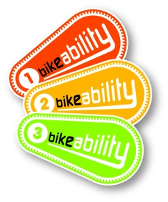
Andrew Crossley (Bikeability Training Manager)
andrew.crossley@cyclenorth.org.uk
Mobile: 07504 282133

Bike Check
Is the bike alright to use?

The cycle training can be done on any sort of bike so long as it is roadworthy, and has both a front and back brake. Please check your bike using the checklist below. If in doubt take it to a bike shop and ask them to check it. Our trainees are not mechanics, but may be able to make minor adjustments on the day. Unfortunately, if your child arrives with a bike that we do not consider safe to use on the roads, your child will not be able to do the training unless you have booked a loan bicycle with us.

This list is not comprehensive and does not guarantee your bike is safe.

Wheels and tyres:

- Check the tyres are pumped up. You should not be able to squeeze the sides of the tyres in.
- If a tyre has large cuts in it, it should be replaced.
- Are the wheel nuts tight, or the quick release levers closed? If they are and the wheels still wobbles from side to side. Get it fixed at a bike shop.
- Get any broken or very loose spokes fixed.
- The wheels should spin freely without the rim or tyre hitting anything such as the brakes or mudguards.

Brakes:

- Make sure that your child can operate the brakes comfortably.
- Try pushing the bike back and forth with the brakes on, there should not be much movement.
- Check that the brake levers do not touch the handlebars when pulled on. If they do they will need adjusting.
- Check the brake blocks are hitting the rim squarely. If they don’t or they touch the tyres, get them adjusted.

Handlebars and saddle:

- Check that you can’t see a maximum mark on the tubes holding the handlebars and saddle.
- Check the handlebars will not turn in their tube, if the front wheel is held tightly.

Does the bike fit:

- Your child should be able to comfortably stand over the bike.
- The saddle should be high enough so that the child’s leg is only slightly bent at the bottom of the pedal stroke.

If you need further information please contact us. It is important that bikes are roadworthy, but it’s more important that your child receives the cycle training. Remember if you do not have a suitable bike we can provide one for you (as long as you let us know on the consent form).

BIKEABILITY CYCLE TRAINING

Parent or Guardian Consent form

Return this whole sheet to your child’s school

Your child’s name: _____________________________________

Class: _____________________________________

Medical Information
Please tell us of any medical condition which we should know about in the box below. For example poor eyesight, asthma, epilepsy, impaired hearing etc. It is unlikely that a medical condition will prevent your child from receiving training.

Please read and sign the following declaration

I have read and understood the letter to parents.

I will check my child’s cycle to ensure it is roadworthy and I am responsible for keeping it roadworthy throughout the course. I authorise instructors from Cycle North to carry out minor adjustments to the cycle.

I understand my child will be trained on public roads, wearing a high visibility top and will be supervised at all times. The training may also include an off-road bike ride at the end of the course or to access an appropriate training area i.e a park, cycle path etc.

I accept that Cycle North can refuse to teach my child if their behaviour or ability level is deemed to be unsuitable.

I understand that Cycle North will not be liable for any loss or damage to trainees’ cycles and other belongings.

Trainees should not be considered safe to ride in all traffic conditions at the end of the course, but please encourage them to practise and supervise them if possible and their confidence will improve further.

Please tick the box if you wish your child to have loan of a bike helmet □
Please tick the box if you wish your child to have loan of a bike □
Please tick the box if your child can not ride a bike □

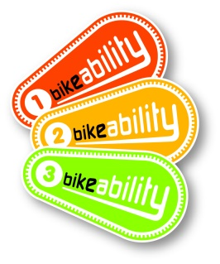
Signed: ________________________

Date: ________________________

