
Geography Policy
Subject Leaders: Hamish Malcolm and Collette Robinson
The importance of Geography

‘Geography is not a narrow academic subject for the few. It is fundamental for everyone. It starts very early, when a young child encounters and begins to discover the world. Geography can nourish and enrich a whole lifetime of learning.’
- A Different View, Geographical Association

Studying geography in depth is vital for children as it helps to make sense of the world around them and evolves a curiosity in places, people, human and physical geography. Furthermore, through conducting enquiry-based fieldwork and learning map skills, children gain resilience and become independent and challenging thinkers. Finally, geography engages pupils in their world and encourages them, and equips them, to become global citizens of the future.
Intent: what is our curriculum aspiring to achieve?

In early years and foundation stage we base our geography curriculum through the EYFS Framework. Children will start to understand their surroundings and the world, study people, places and communities and begin to look at the natural world. At Walkley, the children will begin to be introduced to key concepts which will be built through each year at Walkley.
At the core of our Key stage 1 and 2 curriculum is of course the national curriculum. The subject content of the geography national curriculum is separated into what children need to have learnt by the end of Key Stage 1 (year 2) and what children need to have learnt by the end of Key stage 2 (year 6). It breaks down the learning into four strands: 1. Locational knowledge, 2. Place knowledge, 3. Human and physical geography and 4. Geographical skills and Fieldwork. Furthermore, the concepts children should grasp are:
- Place
- Space
- Scale
- Interdependence
- Physical and Human Processes
- Environmental Impact
- Sustainable Development
- Cultural Awareness
- Cultural Diversity

Walkley has created an ambitious and stimulating geography curriculum that delivers the national curriculum in a coherent meaningful way, builds on prior learning and encourages enquiry and critical thought.

Our vision for Geography

Implementation: what do we do to deliver our intent?

Walkley has researched and sought advice and training from Learn Sheffield, King Edwards Secondary school’s Geography department and the Geographical Association to build a curriculum which is progressive and well sequenced. Factors such as how to ensure children’s short-term memory is not overloaded in lessons and how to maintain that knowledge taught becomes “sticky” were carefully considered when building the school curriculum. Furthermore, a key aim for our curriculum is for substantive knowledge (facts, information) and disciplinary knowledge (links to the real world, professions and “working like a geographer”) are taught in a meaningful and integrated way.
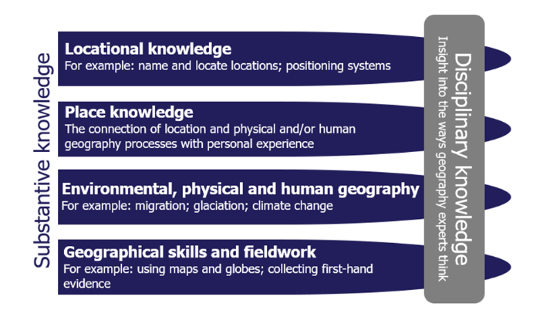
We also looked at Iain Freeland HMI, Ofsted’s subject lead for geography, report on Geography in outstanding schools (https://educationinspection.blog.gov.uk/2021/05/11/geography-in-outstanding-primary-schools/.) In the report the general trend was that schools were strong in creating a curriculum which built on previous learning. However, in Key Stage 2, many schools were viewed to not be teaching map work effectively. Furthermore, examples of field work studies were viewed to miss opportunities of learning and did not have clear objectives. As the report explains, “That’s not to say that pupils did not visit different places, but, when they did, they did not make the observations or collect data that they could analyse and present their findings.”
Finally, the report identified that few primary schools were working with secondary skills to develop their curriculum and prepare their children for the next phase in their education.
This has made it clear that links with a secondary school, map reading and fieldwork are key for Walkley to resource, plan and teach geography in a thought-provoking and robust way.

Structure of Lessons

Geography lessons at Walkley Primary School consist of:
- Reference to prior learning;
- Enquiry questions
- Use of atlases, maps, Google Earth/Maps and Digimaps
- Teacher input to develop knowledge and skills in order to meet the lesson objective;
- Independent tasks to develop children’s understanding of key skills;
- A plenary to consolidate the learning.

Approaches to Learning
Within Geography lessons, children will be asked a key question which frames the context of the lesson (from the Key Knowledge progression document). The Learning Objective highlights the geography skill or knowledge that children will practise (selected from the Key Skills progression map). During their lessons, they will produce work using a variety of methods, including, but not limited to: group discussion, speaking and listening, photos, map reading, use of the forest school and use of ICT through both iPads and Chromebooks. Planning, carrying out and evaluating fieldwork is an essential opportunity for enriching and extending learning and each year group will have at least one opportunity per academic year.

Planning
Mapping out the progression of skills and knowledge
Walkley has carefully mapped out the key knowledge skills and concepts which each year group should teach and build on.
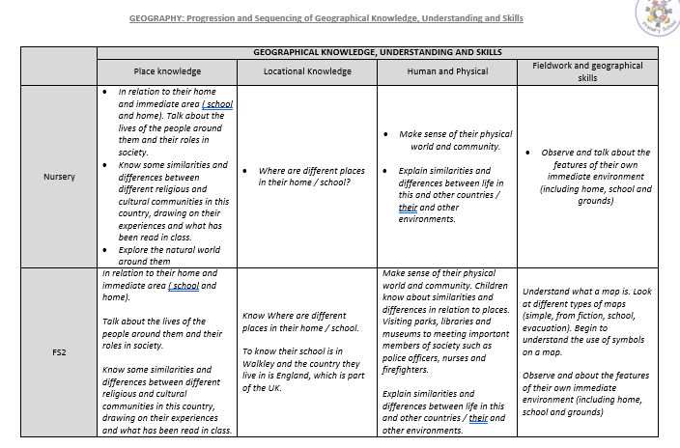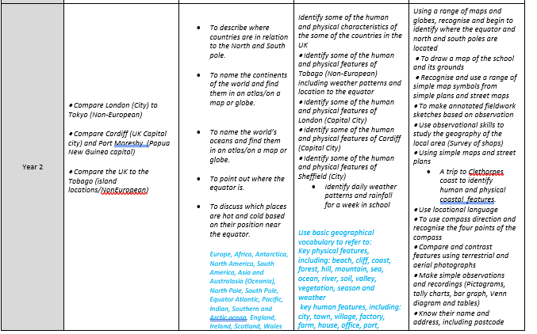
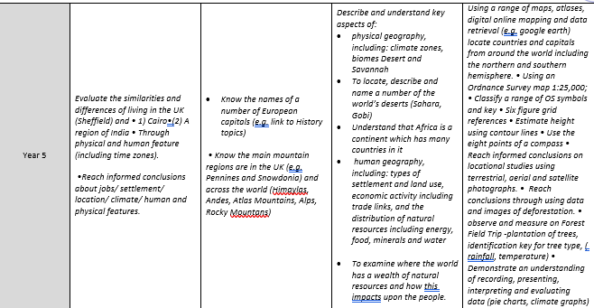
This document is vital as it breaks down how knowledge and skills are built on throughout a child’s learning journey at Walkley school. It ensures that skills and knowledge are carefully built on and that children will have all the geography skills and knowledge required for the the start of secondary school.
For example, in year 2 in map skills, children look at basic maps of the school and use 4 points of compass to locate different places. By year 6, children will be using OS maps and will identify places using the 8 points of a compass and follow 6 figure grid references.
Furthermore, the map breaks down the 3 concepts of place, space and environment and how each year, knowledge and skills are built on to make children have a greater understanding.

Walkley School Wider Curriculum Map
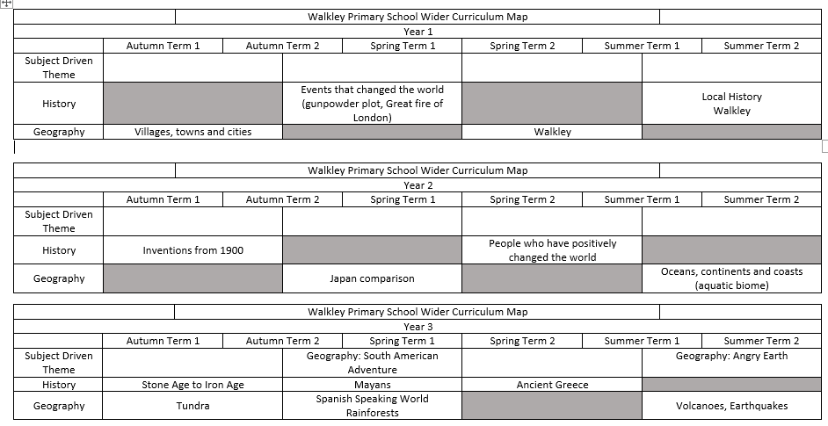
Subject leaders and SLT worked together to map out geography, history, dt, computing, art and RE. Geography topics were based on the knowledge and skills required for each year group. Topic titles included e.g. Wonderful Walkley!, Rivers and Mountains and What is the Commonwealth?
Progression and sequencing of Key knowledge document
The next document which was produced was the progression and sequencing of Key knowledge which built on the progression of skills document and added more depth and detail to how knowledge would taught and crucially where it would be taught in the different geography topics.
A statement from Ofsted’s Ian Freeland of, “When knowledge gets personal it becomes sticky” was a key aim for Walkley’s curriculum. For example, when learning about villages, suburbs, towns and cities it made sense to focus on our school, Walkley and then Sheffield. We also tried to make fieldwork enquiry based and relevant to our children. For example, Y4 children will look at the speed, depth and the possibility of flooding at one part of the Rivelyn river and Y3 children will look at whether South Road needs another zebra crossing by collecting data on the amount of traffic over a period of time.
From these documents teachers, Geography subject leaders created partially completed medium term plans for each year groups geography topics to maintain well sequenced lessons which built on prior knowledge and included the key knowledge and skills to ensure meaninful progression in the children’s learning. Class teachers were then expected to to research, plan in more detail and produce resources for lessons with guidance from subject leaders.

Resources
Walkley has invested in a variety of resources to particularly improve the teaching of map and fieldwork skills. We subscribed to Digimaps which is a fantastic online tool which gives us access to 1000s of maps worldwide including OS, satellite and historical. We have also bought a class set of compasses. Finally, for fieldwork, we have purchased water guages, large thermometers and humidity sensors to assist us with analysing weather and climates.
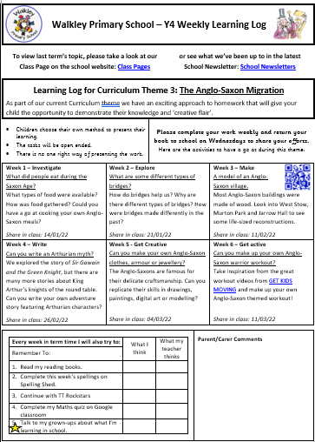
Homework

As part of our regular homework package, teachers set more open-ended tasks designed to develop children’s wider-curriculum knowledge and skills through six tasks which may presented in a homework book (Learning Log) or through Google Classroom. These wider-curriculum homework tasks are set alongside Geography or History Themes, which means that the six tasks might be spread over a longer period. For example, a theme might run for eight weeks, which allows for some tasks to be spread over two weeks to allow children more time to complete larger projects.

Impact: how do we ensure that children are learning?
All pupils have access to the geography curriculum, with all children having equal worth regardless of culture, gender, race, academic ability or disability. We have focused on making our geography curriculum celebrate the diversity of our local community and celebrate the diversity of our world. Work is accessible through adaptive teaching where images and scaffolded resources are used to ensure that reading and writing are not barrier to accessing geographical skills and knowledge.

Monitoring and review

Geography teaching will be monitored by the Geography subject leaders and SLT on a termly basis. This will be done through learning walks, analysis of the Milestone data on the PiTA grids, book scrutiny and planning scrutiny to ensure that:
• the policy is applied by all staff;
• Milestone objectives are addressed;
• sessions are pitched at the level appropriate for the group;
• sessions are delivered in line with the agreed lesson sequence;
• accurate assessments are made of children’s achievements;
• assessment information is used to inform future planning.

Responsibilities

Teaching staff have a responsibility to ensure that sequences of Geography lessons are planned, delivered and assessed as outlined in the policy.

Teaching assistants have a responsibility to deliver planned group sessions and provide feedback to teaching staff regarding the progress, engagement, misconceptions and achievements of the children.

Supply teachers have a responsibility to ensure that Geography lessons are planned, delivered and assessed as instructed by teachers in line with this policy.

Subject leaders and SLT have a responsibility to monitor whole school application of the geography policy by all staff and ensure observed practice is effective. They will also deliver CPD when necessary and a termly book scrutiny and pupil interviews.

