VCOP
LO | To brainstorm ideas | What I think | What my teacher thinks
 | Include information about their early life | ⃝
 | Include information about the fauvist art movement in their early career | ⃝
 | Include information about when Matisse became ill and the challenges that he faced as a painter | ⃝
 | Include information about Matisse’s cut outs and his old age | ⃝
 | Complete the VCOP | ⃝
Vocabulary:
Connectives:
Openers:
Punctuation:

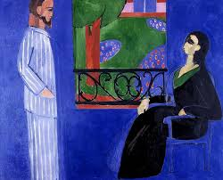

Challenges/
Illness:

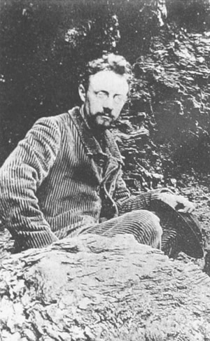
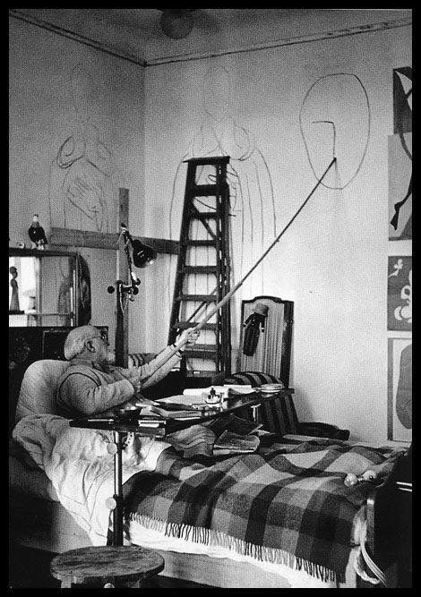
Early life:
Cut outs/old age:
Early career:

