Vocabulary: Biography of Henri Matisse
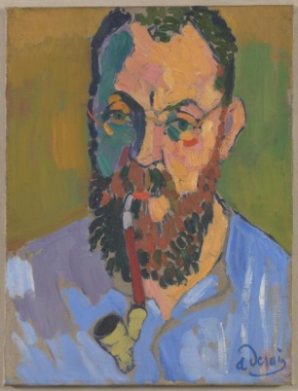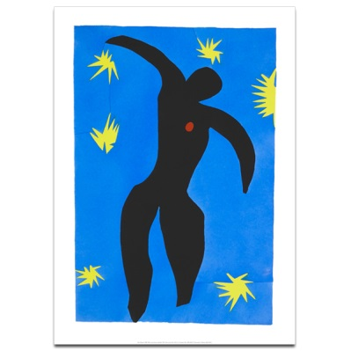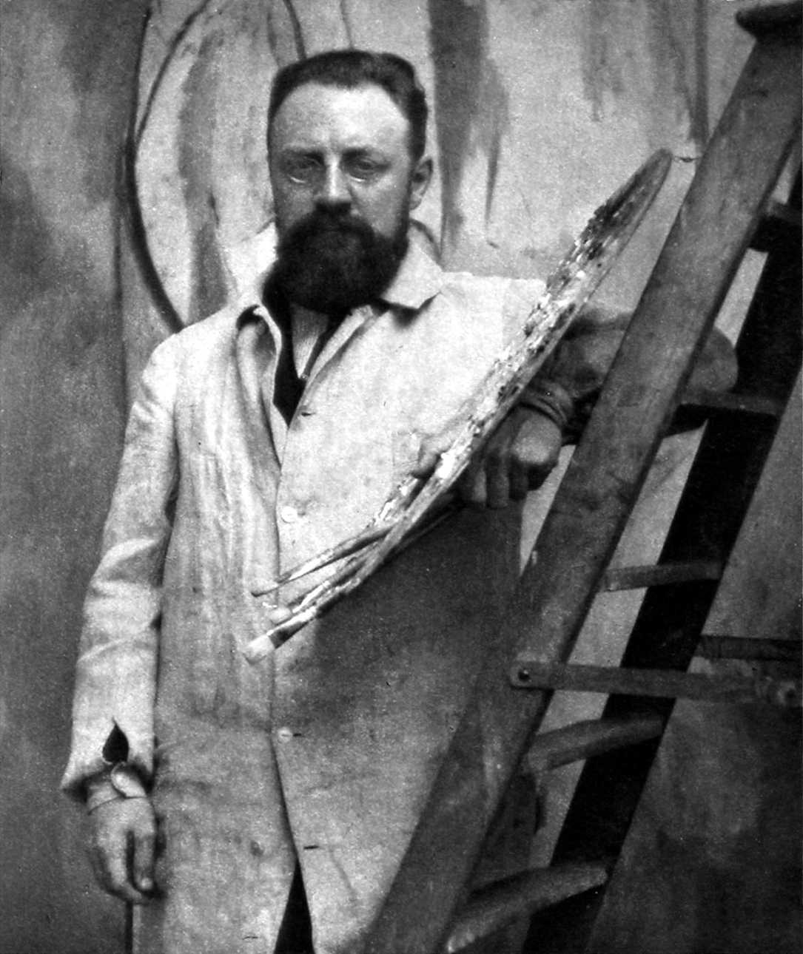
Prosperous - having wealth, success, or good fortune. | Grain - the small hard seeds of cereal plants such as wheat or rice | Merchant - someone who buys goods and sells them for a profit

