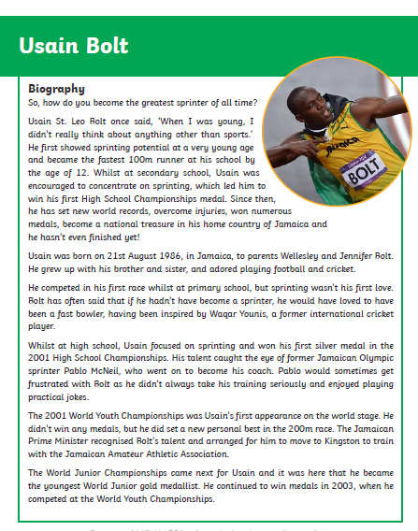
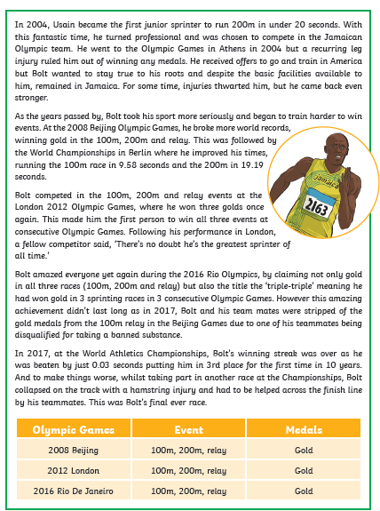
Biographies are always written in chorological (time) order and include important events from the subject’s life.
Draw a timeline and label it with key events and dates from Usain Bolt’s life

Here are some of the other important features of a biography. Can you find some examples of each of these?

Question or interesting opening statement to hook the reader
_______________________________________________
Summary of the main events of the person’s life, including:

• their main achievements
_______________________________________________
• personality
_______________________________________________
What they are remembered for
_______________________________________________

What about the grammar of a biography? Can you find some examples of the following grammatical features? Find a few examples for each but not all of them!
Written in the past tense:
Uses third person pronouns:

