Caterpillar update: (Wednesday)
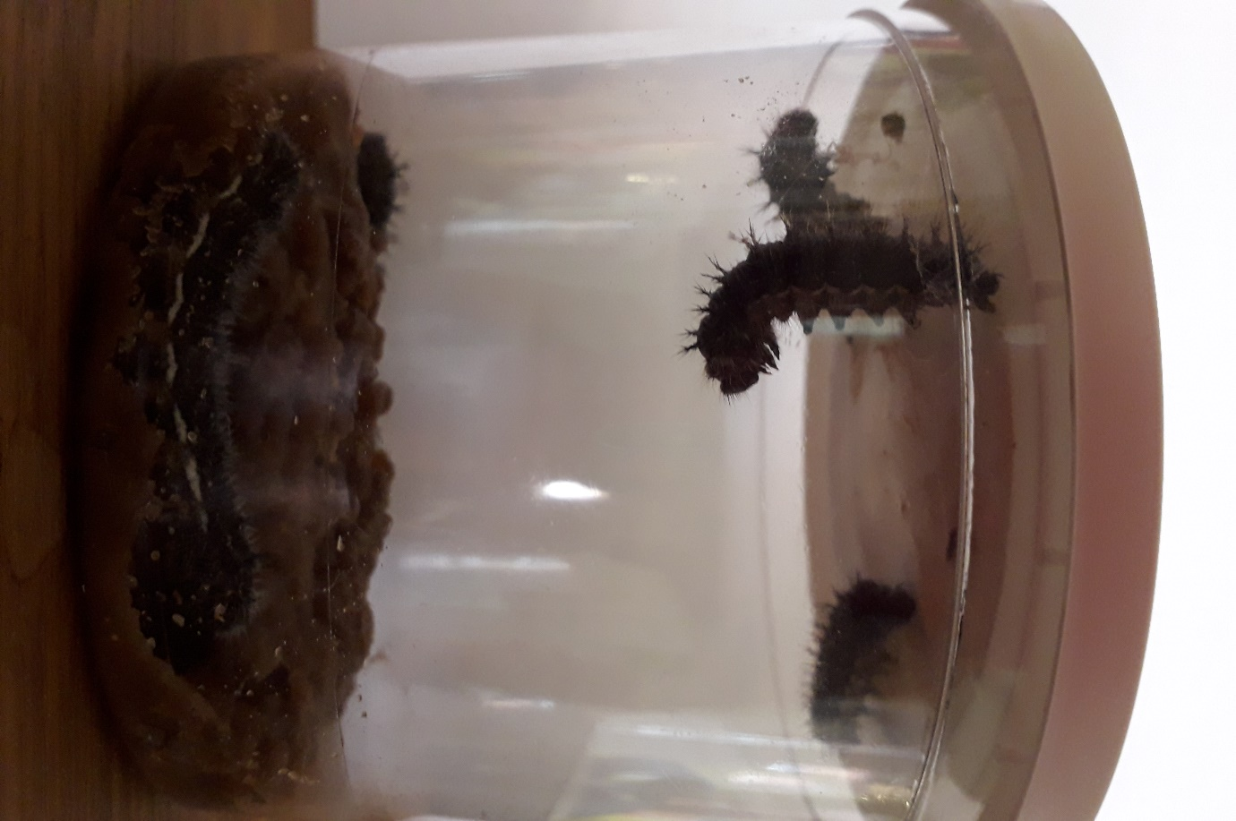
Well they have grown loads and are at least 4cm long now. You can see that one caterpillar has attached itself to the lid of the cup and is hanging in a ‘j’ shape…this is what they do just before they turn into a chrysalis. Not long now!

