Caterpillars (Thursday)
We woke up this morning to find a chrysalis! Also two more caterpillars in their ‘j’ shape about to change:
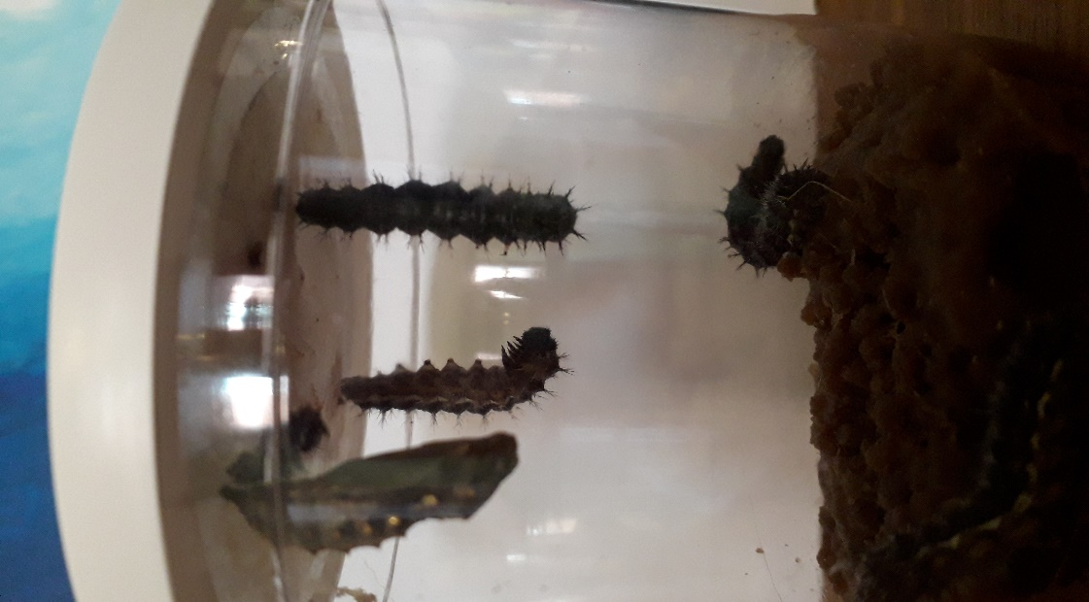
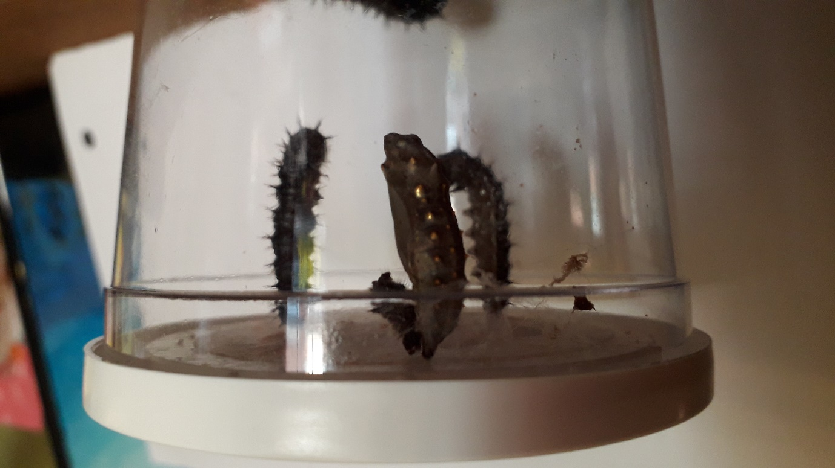
I find it absolutely amazing how this can happen. Nature is pretty fantastic!

