Hi, Mrs Goff here.
Just before lockdown began I ordered some caterpillars for my daughter. I was very surprised when they arrived last Monday. They were very tiny, less than 1cm long, like bits of thread. I thought you might like to see what they look like now after 11 days of eating and sleeping:
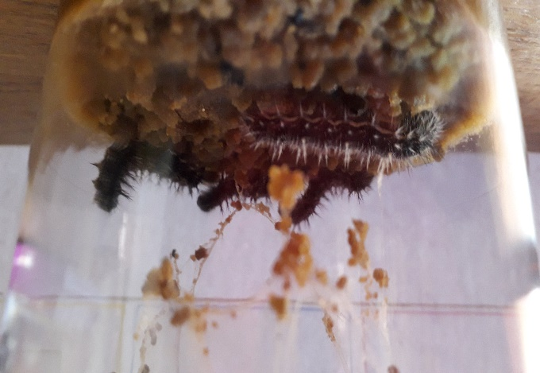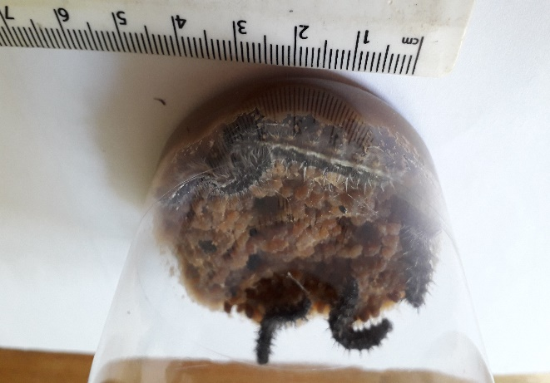
They are over 3cm long, fat and hairy! The brown stuff at the bottom of the cup is their food. They spin a bit of web which they would use to hold them onto leaves on windy days in the wild. Here the web has caught some bits of caterpillar poo! Lovely! If you can remember the Science work we did on lifecycles recently, you will know what will happen to these caterpillars soon…….when it does I’ll send you another picture.
Looking forward to seeing you all soon.

