- Mrs Leverton’s fitness watch recorded the distance she walked each day in metres. Convert each distance to kilometres.

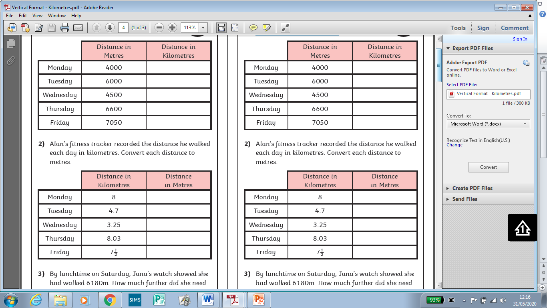

- Mr Gammage’s fitness tracker recorded the distance he walked each day in kilometres. Convert each distance to metres.

- By lunchtime on Saturday, Mrs. Leverton’s watch showed she had walked 6180m. How much further did she need to walk to reach 9km?

- True or false:

Mr. Gammage walked further than Mrs. Leverton on Wednesday.

On Friday, Mrs. Leverton and Mr. Gammage walked the same distance.

