- Jana and Alan measured the distances between their school and different places in their town. Use the information given to convert from kilometres to metres or vice versa using the table.

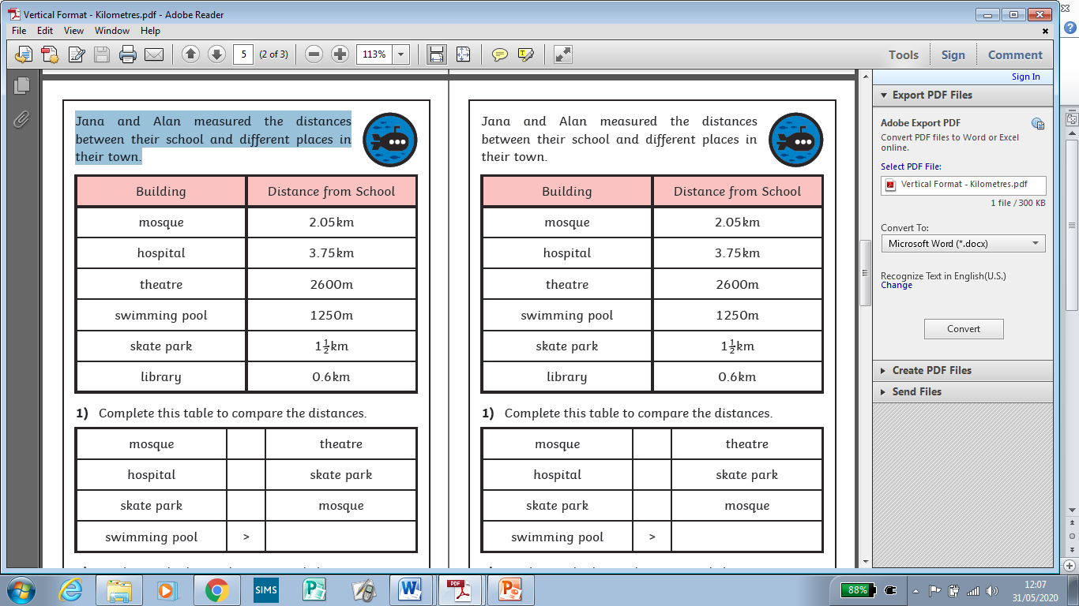

Building | Distance in metres | Distance in kilometres
Mosque |  | 2.05km
Hospital |  | 3.75km
Theatre | 2600m
Swimming pool | 1250m
Skate park |  | 1 ½ km
library |  | 0.6km

- Complete this table using < > = to compare the distances:

- Work out whether each statement below is true or false and explain how you know.

The mosque is 2500m from school.
The theatre is 2000m further away than the library.
The hospital is 3¾km from school.
Three places are more than 2½km away.
The swimming pool is further away than the skate park.

