Ms. Solinger completed a charity travel event using different methods of transport.

- Use the pictures below to find out how far Ms. Solinger travelled using each method.

Use this clue to start you off: Ms. Solinger travelled the same distance on the bus as she did in the car.

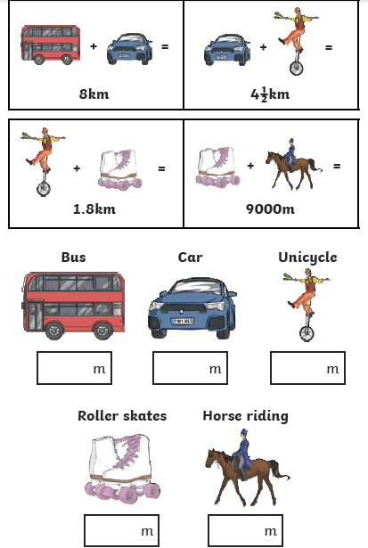

- How far in kilometres did Ms. Solinger travel altogether?

- Have a go at creating your own maths problem like this.

