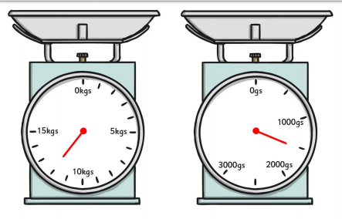
Multiply by 100 to convert the kilograms into grams:
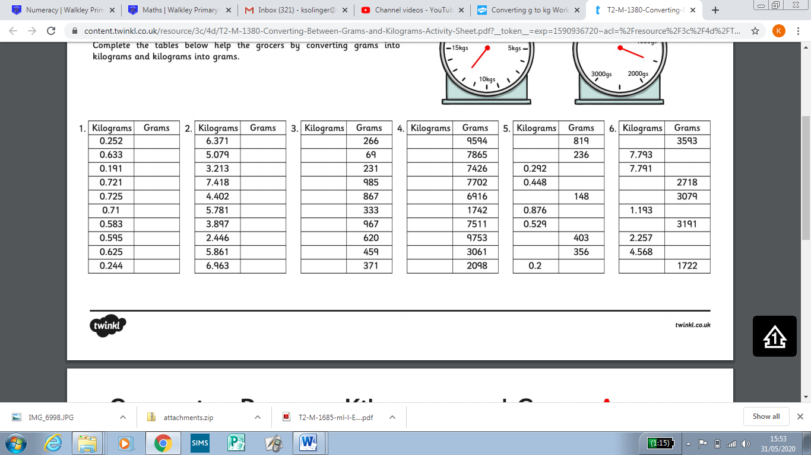
Convert the grams into kilograms

