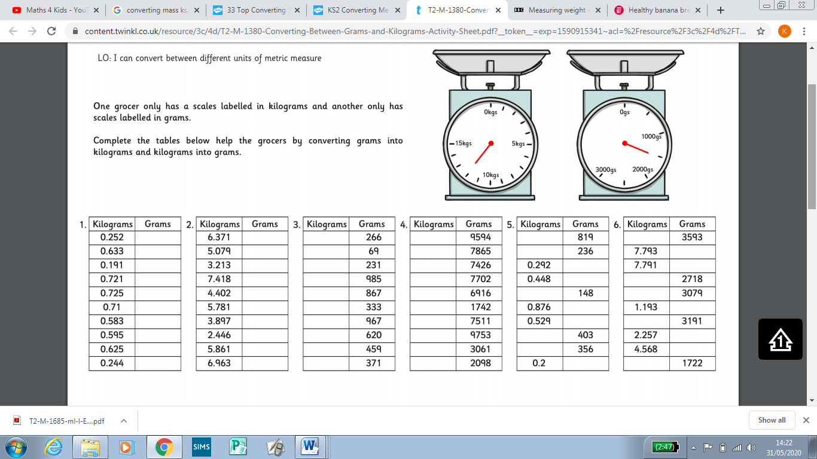
Convert the kilograms into grams
Convert the grams into kilograms

