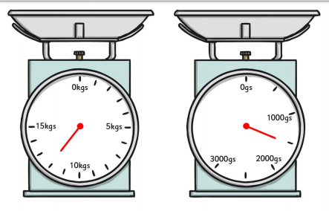
Convert the units of measure
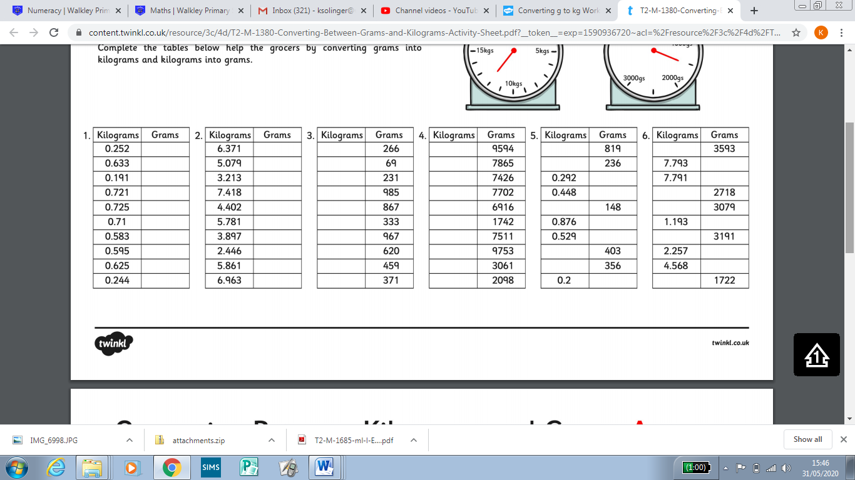
Convert the units of measure, working with amounts less than 1

