Find the missing values on the double number line:
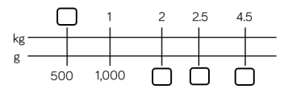
5.04
4.2
3.5
750

Complete the missing information:
3/10 kilogram = _____ grams
¾ kilogram = _____ grams
7 kg + ¼ kg = ____g
12kg + _____kg = 12,500g

Compare the measurements using < > =
8.07kg ⃝ 8700g
4.545 kg ⃝ 4500g
2.899kg ⃝ 2900g
8.072kg ⃝ 8702g

Reasoning and problem solving extension:


