Find the missing values on the double number line:
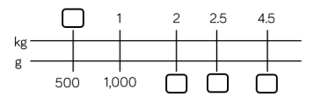
6.7
5
3.5
500

Complete the missing information:

1/10 kilogram = ____ grams
3/10 kilogram = _____ grams
¼ kilogram = _____ grams
7 kg + ¼ kg = ____g
12kg + _____kg = 12,500g

Compare the measurements using < > =
3kg ⃝ 3,000g
4 kg ⃝ 400g
2.5kg ⃝ 2600g
8.7kg ⃝ 9300g

