Find the missing values on the double number line:
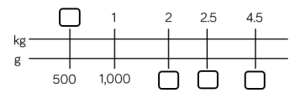
6.7
5
3.5
500

Complete the missing information:

1/10 kilogram = ____ grams
3/10 kilogram = _____ grams
¼ kilogram = _____ grams
7 kg + ½ kg = ____g
12kg + _____kg = 14,500g

Compare the measurements using < > =
3.02kg ⃝ 3200g
4 ½ kg ⃝ 4500g
2.8kg ⃝ 2900g

Reasoning and problem solving extension:


