MULTIPLICATION AND DIVISION CY5
L/O: To be able to use column multiplication to solve problems. | What I  think | My teacher thinks
I can remember to:
Identify the maths that I need to do.
know that the both numbers being multiplied can be partitioned (squiggleworth).
multiply number by the ones digit.
multiply number by the tens digit (smile multiplication)
multiply number by the hundreds digit (smile multiplication)
record the two parts of the answer using the correct place value.
add together these totals to give my final answer.
Record the units of measure.
check my final answer is correct.

 | DO ME FIRST
Circle the common factors of 18 and 27.

1 2 3 5 6 9 10
 | Circle the common factors of 18 and 27.  1 2 3 5 6 9 10 | 1 mark
Here is a recipe for pepperoni pizza – yum, my favourite!
Makes 1
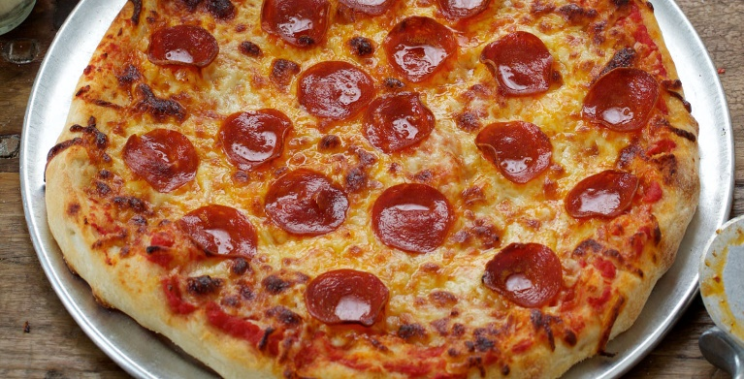
For the base:
- 1 tablespoon salt
- 2g dried yeast
- 12ml olive oil
- 13ml warm milk
- 72ml warm water
- 112g strong white bread flour
For the topping:
- 11 slices of pepperoni
- 32g tinned tomatoes
- 63g grated mozzarella cheese
Work out how much of each ingredient I would need to make:
- 3 pizzas
- 6 pizzas
- 12 pizzas
- 18 pizzas

