MULTIPLICATION AND DIVISION CY5
L/O: To be able to use column multiplication to solve problems. | What I  think | My teacher thinks
I can remember to:
Identify the maths that I need to do.
know that the both numbers being multiplied can be partitioned (squiggleworth).
multiply number by the ones digit.
multiply number by the tens digit (smile multiplication)
multiply number by the hundreds digit (smile multiplication)
record the two parts of the answer using the correct place value.
add together these totals to give my final answer.
Record the units of measure.
check my final answer is correct.

DO ME FIRST
Write the common factors of 18 and 27.

______________________________________________
1 mark
Here is a recipe for pepperoni pizza – yum, my favourite!
Makes 1
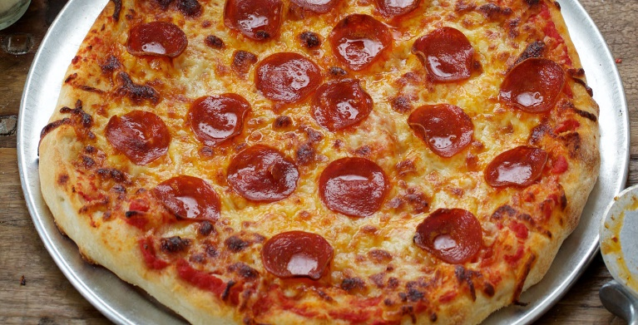
For the base:
- 1 tablespoon salt
- 2g dried yeast
- 12ml olive oil
- 16ml warm milk
- 75ml warm water
- 125g strong white bread flour
For the topping:
- 18 slices of pepperoni
- 38g tinned tomatoes
- 65g grated mozzarella cheese
Work out how much of each ingredient I would need to make:
- 4 pizzas
- 6 pizzas
- 14 pizzas
- 28 pizzas

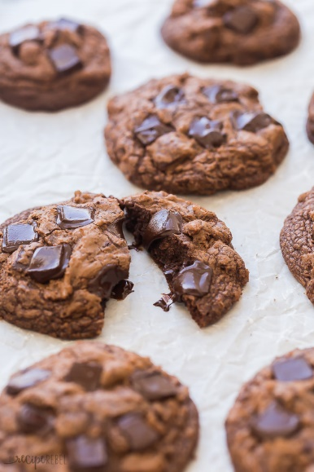
Here is a recipe for making chocolate biscuits – we’ve made lots of sweet treats during lock down!
Makes 12 biscuits
- 1 large egg
- 47g cocoa powder
- 98g of chocolate chips
- 124g unsalted butter
- 162g self-raising flour
- 178g light brown sugar

Look carefully at how many the recipe is for, then see if you can calculate the ingredients for:
- 60 biscuits
- 144 biscuits
- 252 biscuits

