Challenges – Easier
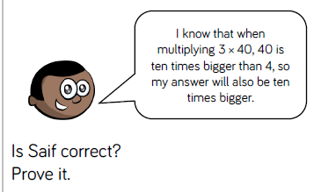
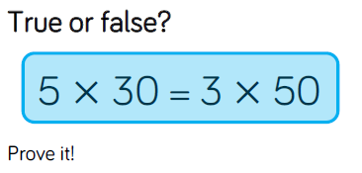
1 2
3
How many ways can you complete ___x___=120

Challenges – Harder
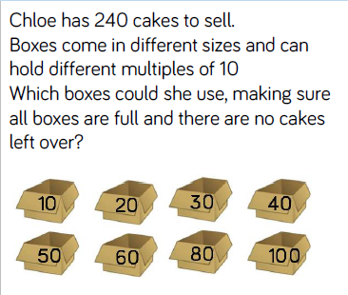
1
2
Why is 34 x 10= 340 but 3.4 x 10 does not =3.40?
3
I think of a whole number and multiply it by 200. My answer is 420. Explain why I must have made a mistake.

