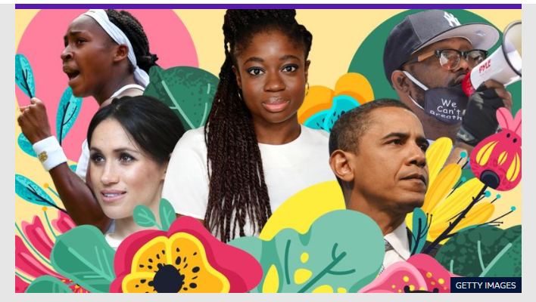
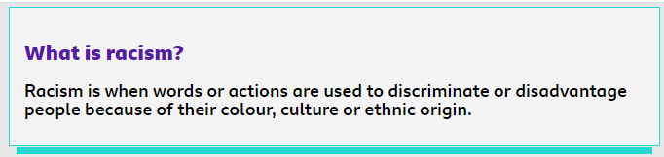
Discriminate: to treat a person or particular group of people differently, especially in a worse way from the way in which you treat other people, because of their skin colour, sex, sexuality, etc.
Powerful: having a lot of power to control people and events
Protest: a strong complaint expressing disagreement, disapproval, or opposition:
Violence: actions or words that are intended to hurt people
Educate: to teach someone, especially using the formal system of school, college, or university
Action: the process of doing something, especially when dealing with a problem or difficulty
Brutality: behaviour that is very cruel or violent and showing no feelings for others, or an act of this type
Potential:
Peacefully:
Solidarity:
Compassion:

