TASK 1: Guided reading – Anti-Racism Speeches
LO: to be able to explain unknown vocabulary | What I  think | My teacher thinks
I can remember to:
Read the speeches and see if you can figure out the meaning from how they are used in the text | ⃝
Use a dictionary by looking up words in alphabetical order | ⃝
Write a clear definition of the word | ⃝
Extension: write an example sentence to use the word in context | ⃝
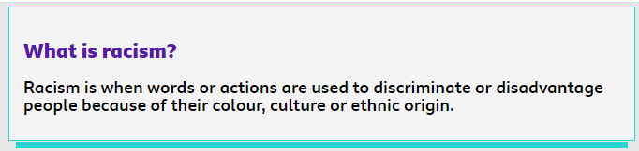
The definition of racism is explained really clearly in the text but there are lots of important words that need to be explained. Can you use the word list to create a glossary to help any other readers to understand the key vocabulary? Use an online dictionary or your own dictionary if you have one.
TASK 2: Guided reading – Anti-Racism Speeches
LO: to be able to summarise key information | What I  think | My teacher thinks
I can remember to:
Read the Speeches | ⃝
Think about the problems of now | ⃝
Think about how you can help to make a situation better | ⃝
Write in short, clear, concise sentences | ⃝
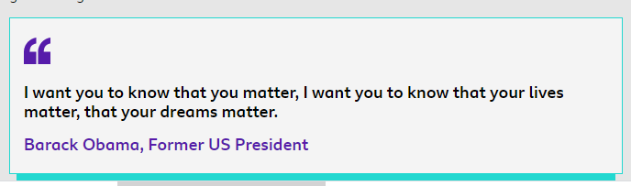
This quote for Barack Obama, shows the importance of young people in this matter. As the next generation, you can directly help to shape the future into a fairer place. Think about what your dreams of a fair and equal future might be and write a short paragraph about how you might help to make the world a better place.

TASK 3: Guided reading – Anti-Racism Speeches
LO: to illustrate important ideas | What I  think | My teacher thinks
I can remember to:
Think about the important values of an equal society | ⃝
Use illustrations that celebrate difference | ⃝
Use a strong slogan (a message to the world) | ⃝
Make your poster bold (stand out) | ⃝



