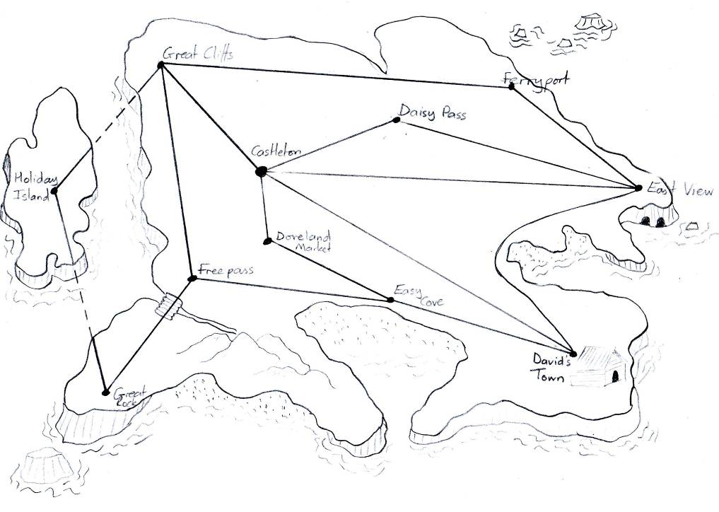
Greycliffs
34km
36km
24km
36km
27km
35km
26km
42km
22km
12km
42km
49km
12km
25km
33km
45km
Holiday
Island
Easy Cove
Great Rock
Freepass
David’s Town
East View
Ferryport
Doveland
Market
Daisy Pass
Castleton

L/O: To solve addition word problems involving measures. (Activity 2)

- How far is the journey from Easy Cove to Great Rock?
- How far is the journey from Daisy Pass to Ferry Port?
- How far is the journey from East View to Greycliffs?
4) How far is it from Castleton to Daisy Pass and then East View?
5) How far is it from Castleton to East View if I travel through David’s Town?
6) How far is the journey from Castleton to Easy Cove?
7) How far is the journey from Freepass to Greycliffs and then Holiday Island?
8) How far is the journey from Freepass to Great Rock and then Holiday Island?
9) I live in Castleton and I’m going to visit my friend in David’s Town. I need to stop at
Doveland Market on the way. How long will my journey be?
10) Pretend you live in Castleton. Plan two different journeys to get to Ferryport. How long is each
route?

Extension
Make your own map and distances (It could be a pirate map, Sheffield..anywhere!!). Then write out different questions and answer them!

