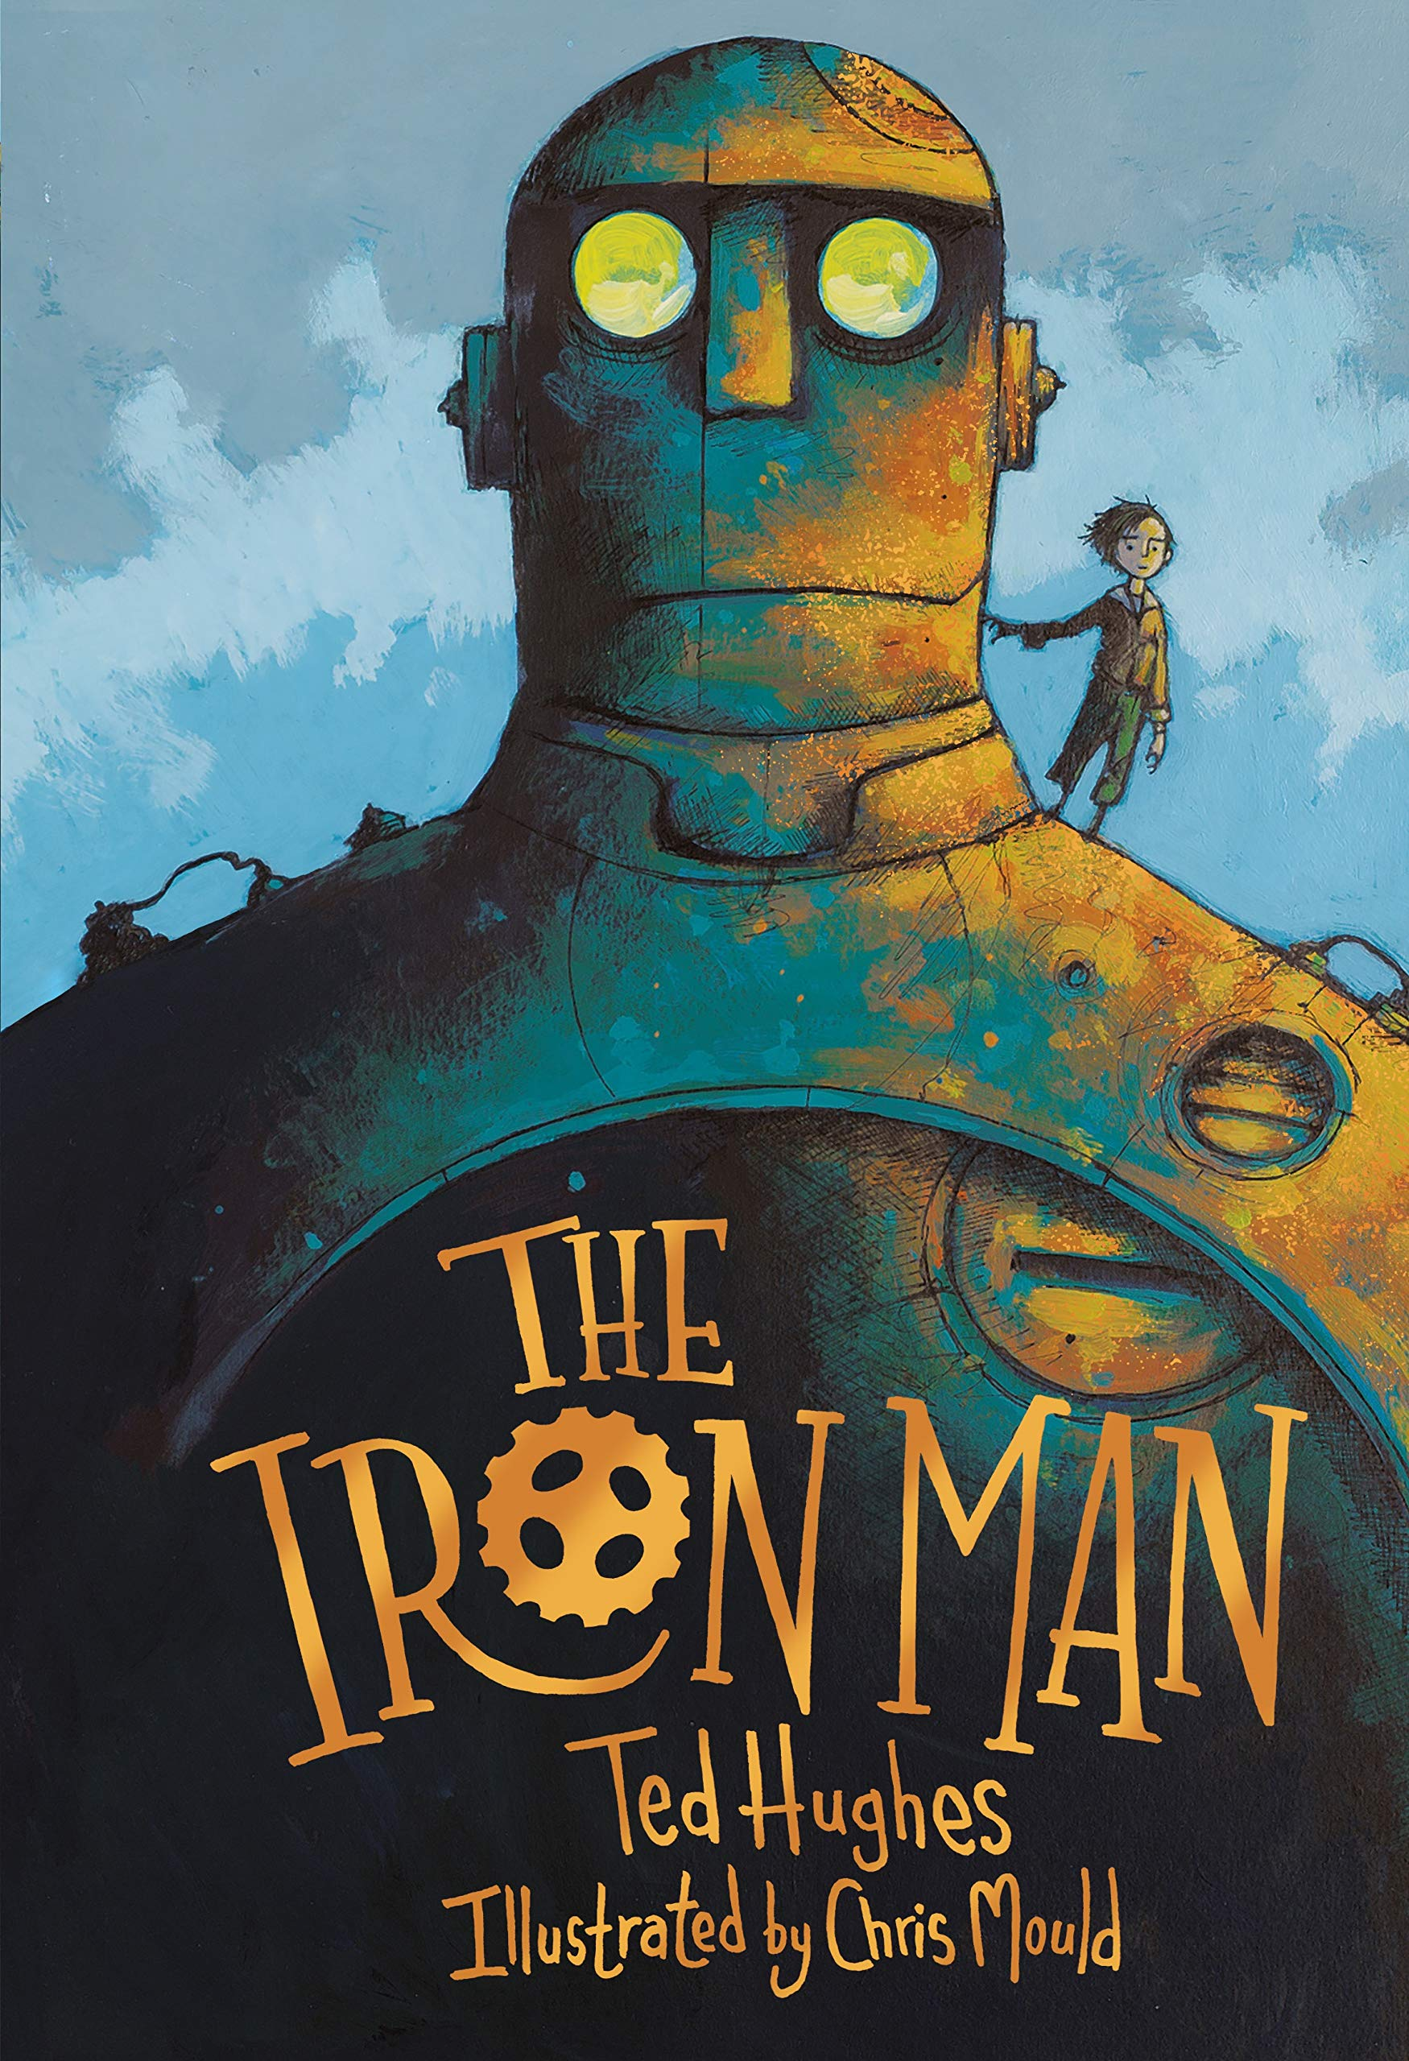 | Observe  I can see__________________________________  ___________________________________________________________.  I can see__________________________________  ___________________________________________________________.  I can see__________________________________  ___________________________________________________________.
Wonder  I wonder__________________________________  ___________________________________________________________.  I wonder__________________________________  ___________________________________________________________.  I wonder__________________________________  ___________________________________________________________. | Infer  I think_____________________________________  _____________________________________________________________.  I think_____________________________________  ___________________________________________________________.  I think_____________________________________  ___________________________________________________________.

