Optional opinion: Is it ever okay to feed pigeons?
What will happen next?

Story
Intro
Missile
What caused it?
Interviews with eyewitnesses

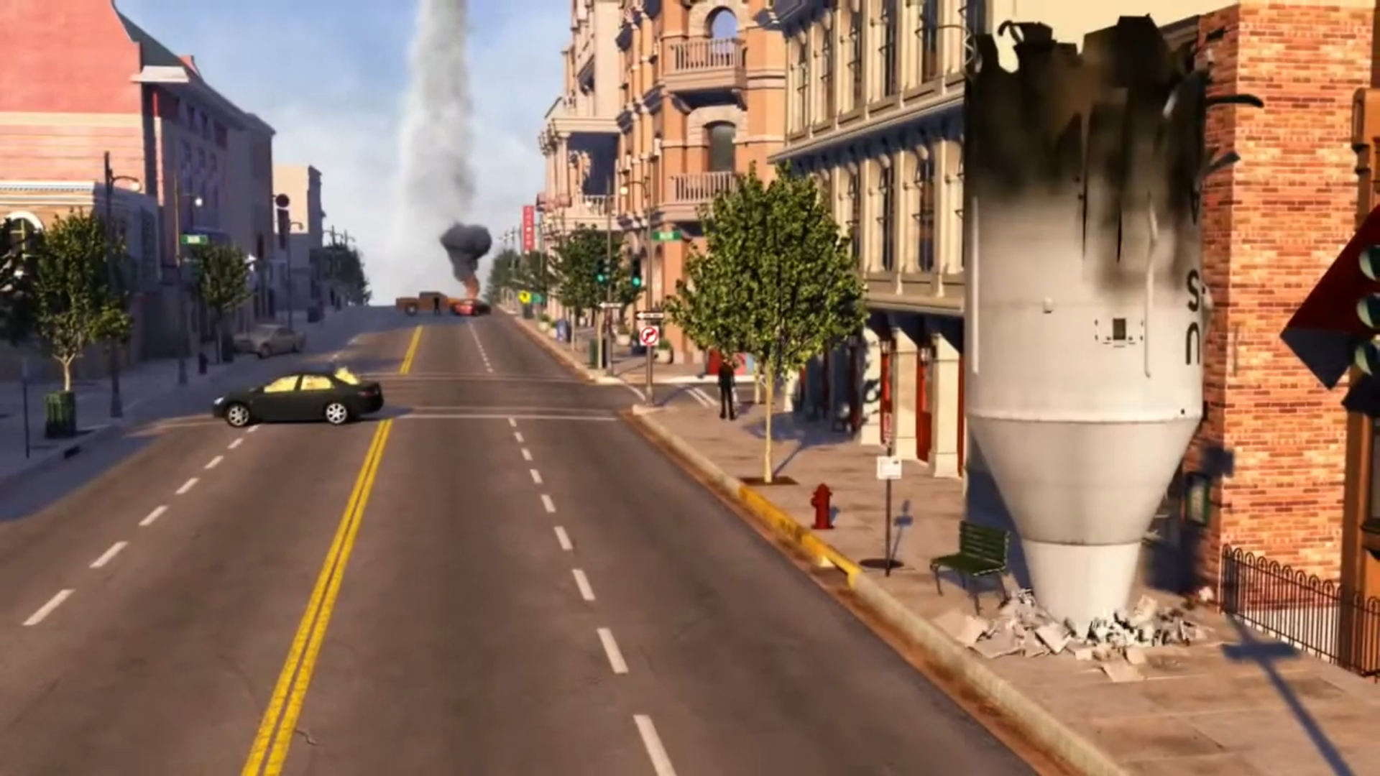
Caption
HEADLINE
Date price¢
THE WASHINGTON POST

