Optional opinion: Is it ever okay to feed pigeons?

Interviews

What next?

Picture & Caption
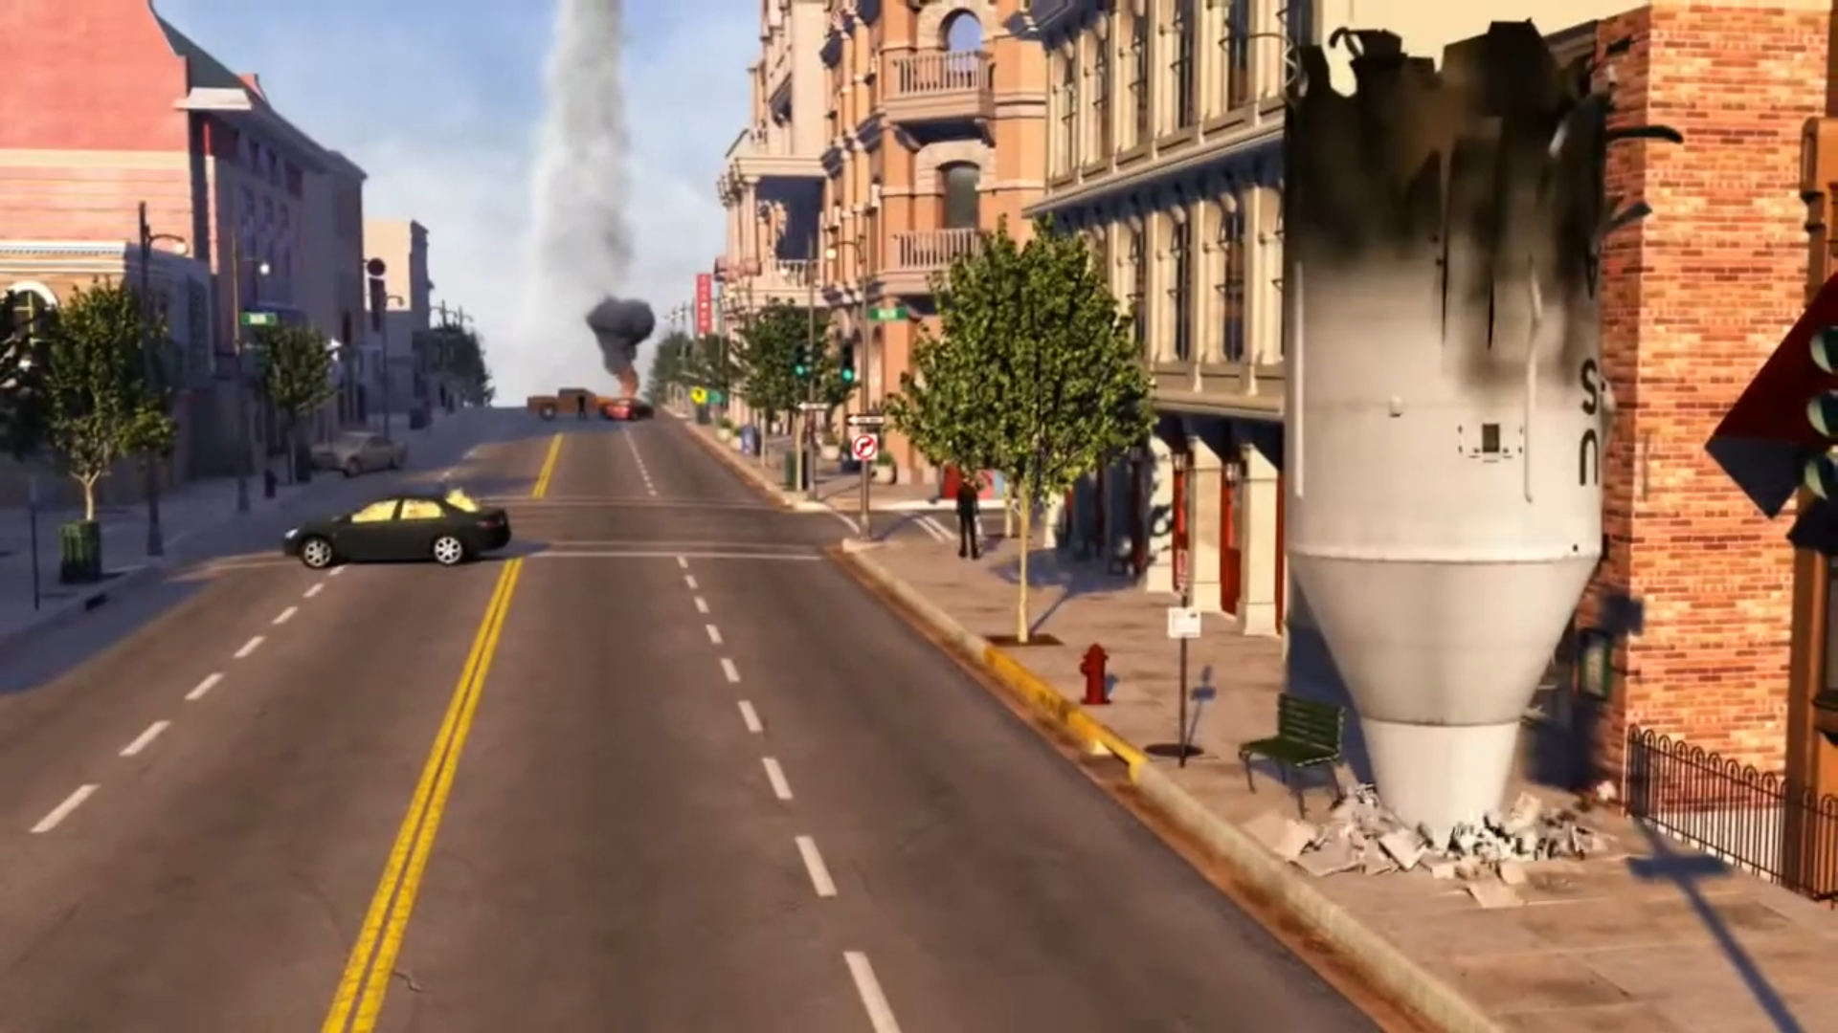
Intro

How?

Why?
HEADLINE
Thursday 21st January 2021 75p
NEWSPAPER NAME

