THE MAKING OF BRITAIN: ANGLO-SAXONS, BRITONS & VIKINGS
LO: To be able to identify features of a good settlement site. | What I  think | My teacher thinks
I can remember to:
sort settlers’ needs by importance.
give reasons why a site might be unsuitable for settlement.
give reasons why a site might be useful as a settlement.
explain how the land could be modified to make a good settlement.
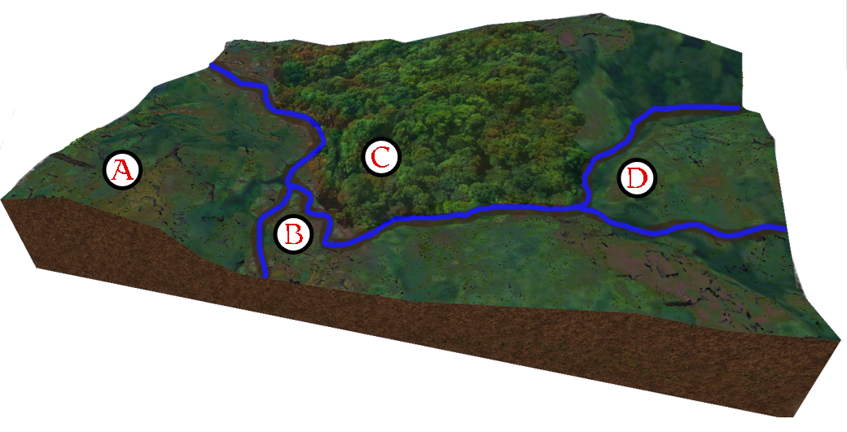
Use your knowledge of the area to choose the best site for each of the settlers’ needs. You should rank them from best (1) to worst (4).
I----------I
10 minutes’ walk
 | Site A | Site B | Site C | Site D
fresh water supply
shelter from the weather
fuel supply
building materials
farmable land
defensible
Choose which site you think is best to settle. You need to persuade your friends and family that your choice is the best.
Write down what you’re going to say to persuade them.

