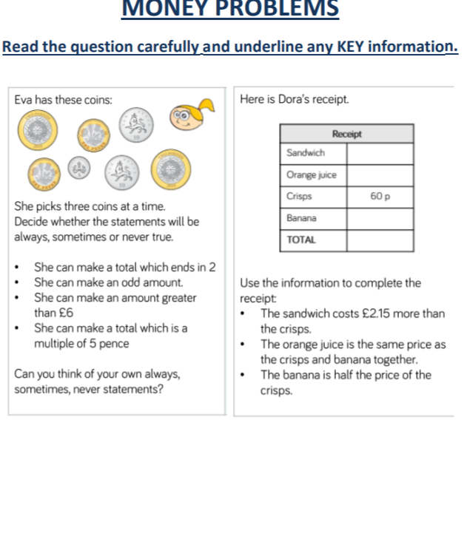
1 never true sandwich 2.75
2 always orange juice 90p
3 never true crisps 60p
4 always banana 30p
Total 4.55

