Maths Homework – Y4 Miss Kendall & Mr Earl - 25/9/2020
Number Line
Can you estimate these numbers on a number line?

- 400

- 6,400

- 5, 200

- 3,260

- 12,800

Learn Its!
This week’s Learn Its to practise are:

Try saying them in different voices (scared, happy, shout, whisper etc.)
How many times can you say each fact in 1 minute?
Play on Time Tables Rockstars to gain your
Rock status!!


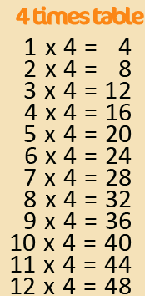

10,000
500
15,000
Challenge
4,000
2,000
6,000
4,000
7,000
6,000
300

