Maths Homework Autumn 1 Week 6
It’s Nothing New
Number Bonds to 10
1 + = 10 2 + = 10
3 + = 10 4 + = 10
5 + = 10 6 + = 10
7 + = 10 8 + = 10
9 + = 10
Remember to use your 10 fingers to help you. 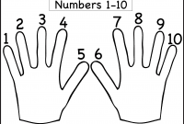

Learn Its!
This week’s learnt Its to revisit are:
1 + 2 = 2 + 3 =
Try counting in 10s:
10, 20, 30, 40, 50, 60, 70, 80, 90, 100
Try saying them in different voices (scared, happy, shout, whisper etc.)
How many times can you say each fact in 1 minute?


