Maths Homework Autumn 2 Week 2
Adding using a number line
Remember to...circle the first number and jump the second number of times:
1. 3 + 4 =
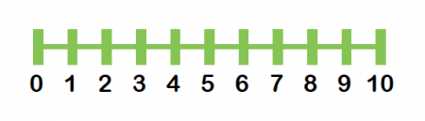
2. 5 + 3 =
3. 7 + 3 =

Counting
Use your counting skills to fill in the missing numbers:



