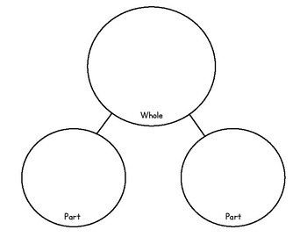
Maths Homework Autumn 2 Week 3
- 7 + 3 = 10
- 3 + 7 = 10
- 10 – 3 = 7
- 10 – 7 = 3

Make your own

2
3
10

10
3
7
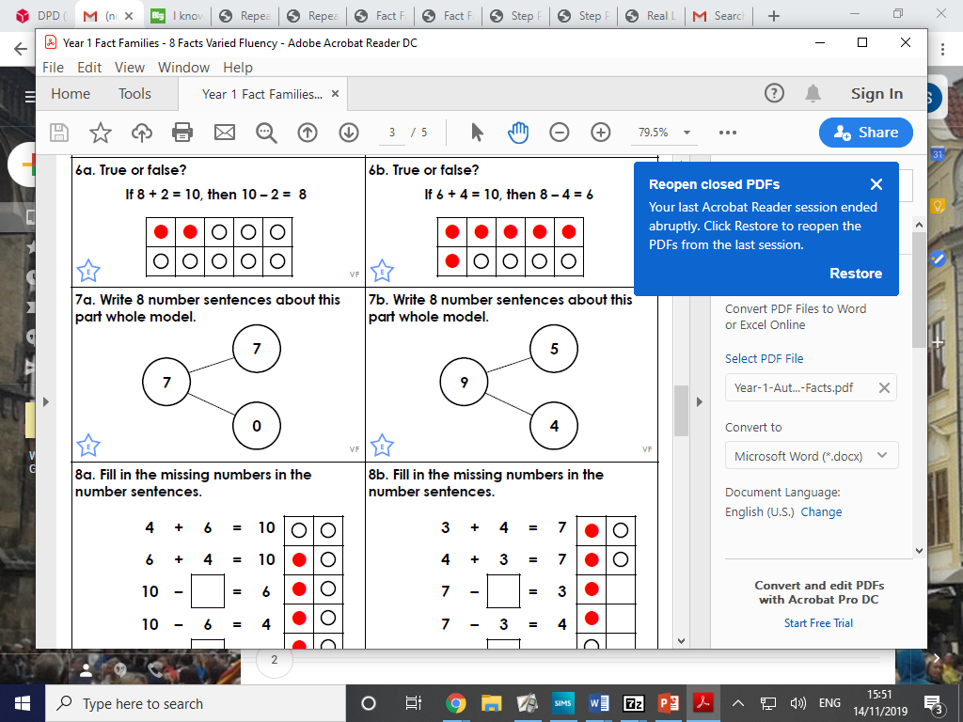
Our addition and subtraction sentences belong to a fact family. In maths you can move numbers around if you know how!



