Science 2/2/21
Learning objective: LO. To identify some common animals
I can remember to... | What I think | What my teacher thinks
To look carefully at the animal skeletons and discuss what type of animal you think it is
Write the name of the animal you think it is next to the correct picture
Identify some similarities between the skeletons/animals
Identify some differences between the skeletons/animals
Who does it belong to?
My Guess
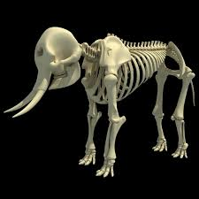
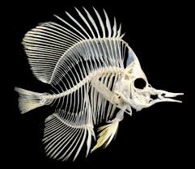
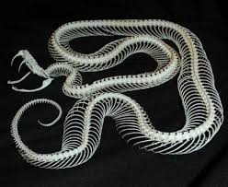
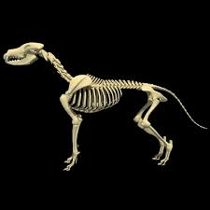

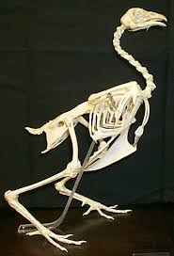
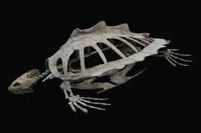

How are they similar? How are they different?

