Maths Homework Spring 1 Week 4 – Year 1
Doubling multiples of ten
Remember to double the number without the 0 and then add it back to your answer:
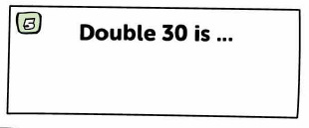
Count back across the 10. Writing the numbers in a list can help:
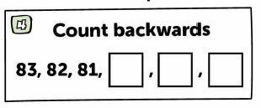

Understanding numbers to 20
Remember to count to find the answer




