Giants Maths Homework Spring 1 Week 1 – Year 1
Counting
Read these numbers to your grown-up:
100 700 900
300 600 200
400 500 800
What can you notice about Pim? (what does everything add up to, how many arms/eyes on each side etc.)
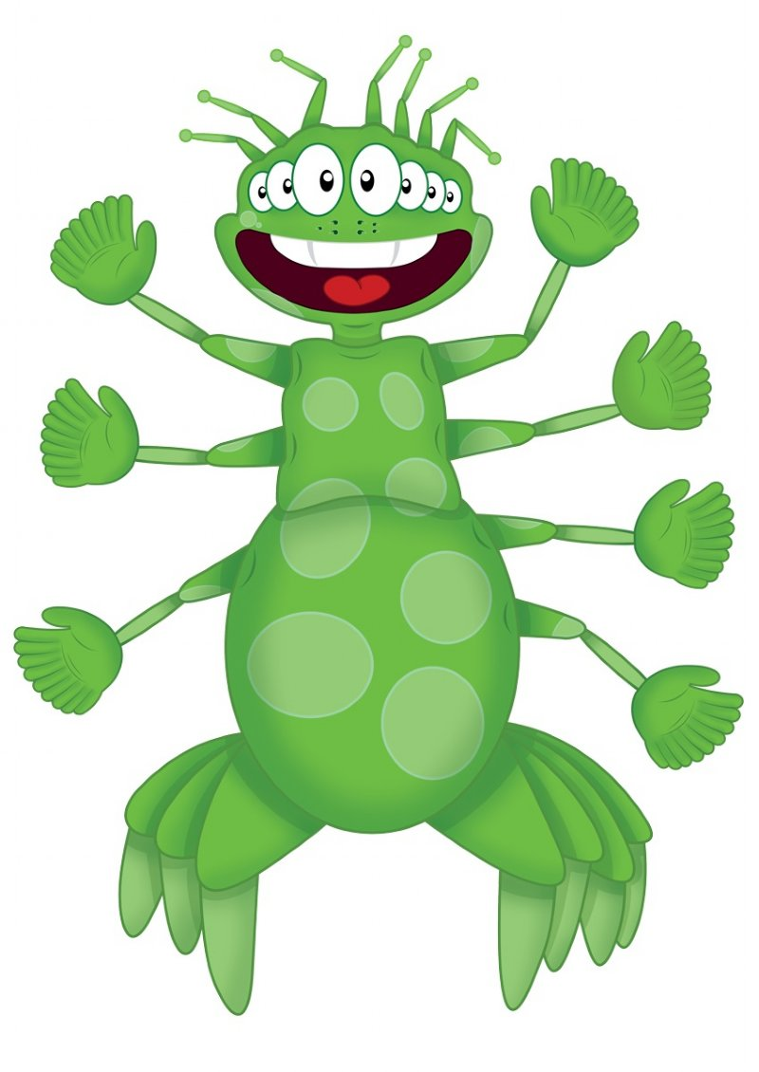
Learn Its!
This week’s learnt Its to practise are:
4 + 2 = 5 + 2 = 6 + 2 =
7 + 2 = 9 + 2 =
Also we need to be able to count in Fives: 5,10,15,20,25,30,35,40,45,50
Try saying them in different voices (scared, happy, shout, whisper etc.)
Can you sing our Learn-its song to your grown up? Teach them how to sing it with you.


